Table of Contents

Tutorial 1: Demand Forecasting 2

Tutorial 2: Capacity Planning and Facility Layout 7

Tutorial 3: Process Design and Facility Layout 10

Tutorial 4: Quality Management and Statistical Control 15

Tutorial 5: Supply Chain Management 22

# Tutorial 1: Demand Forecasting

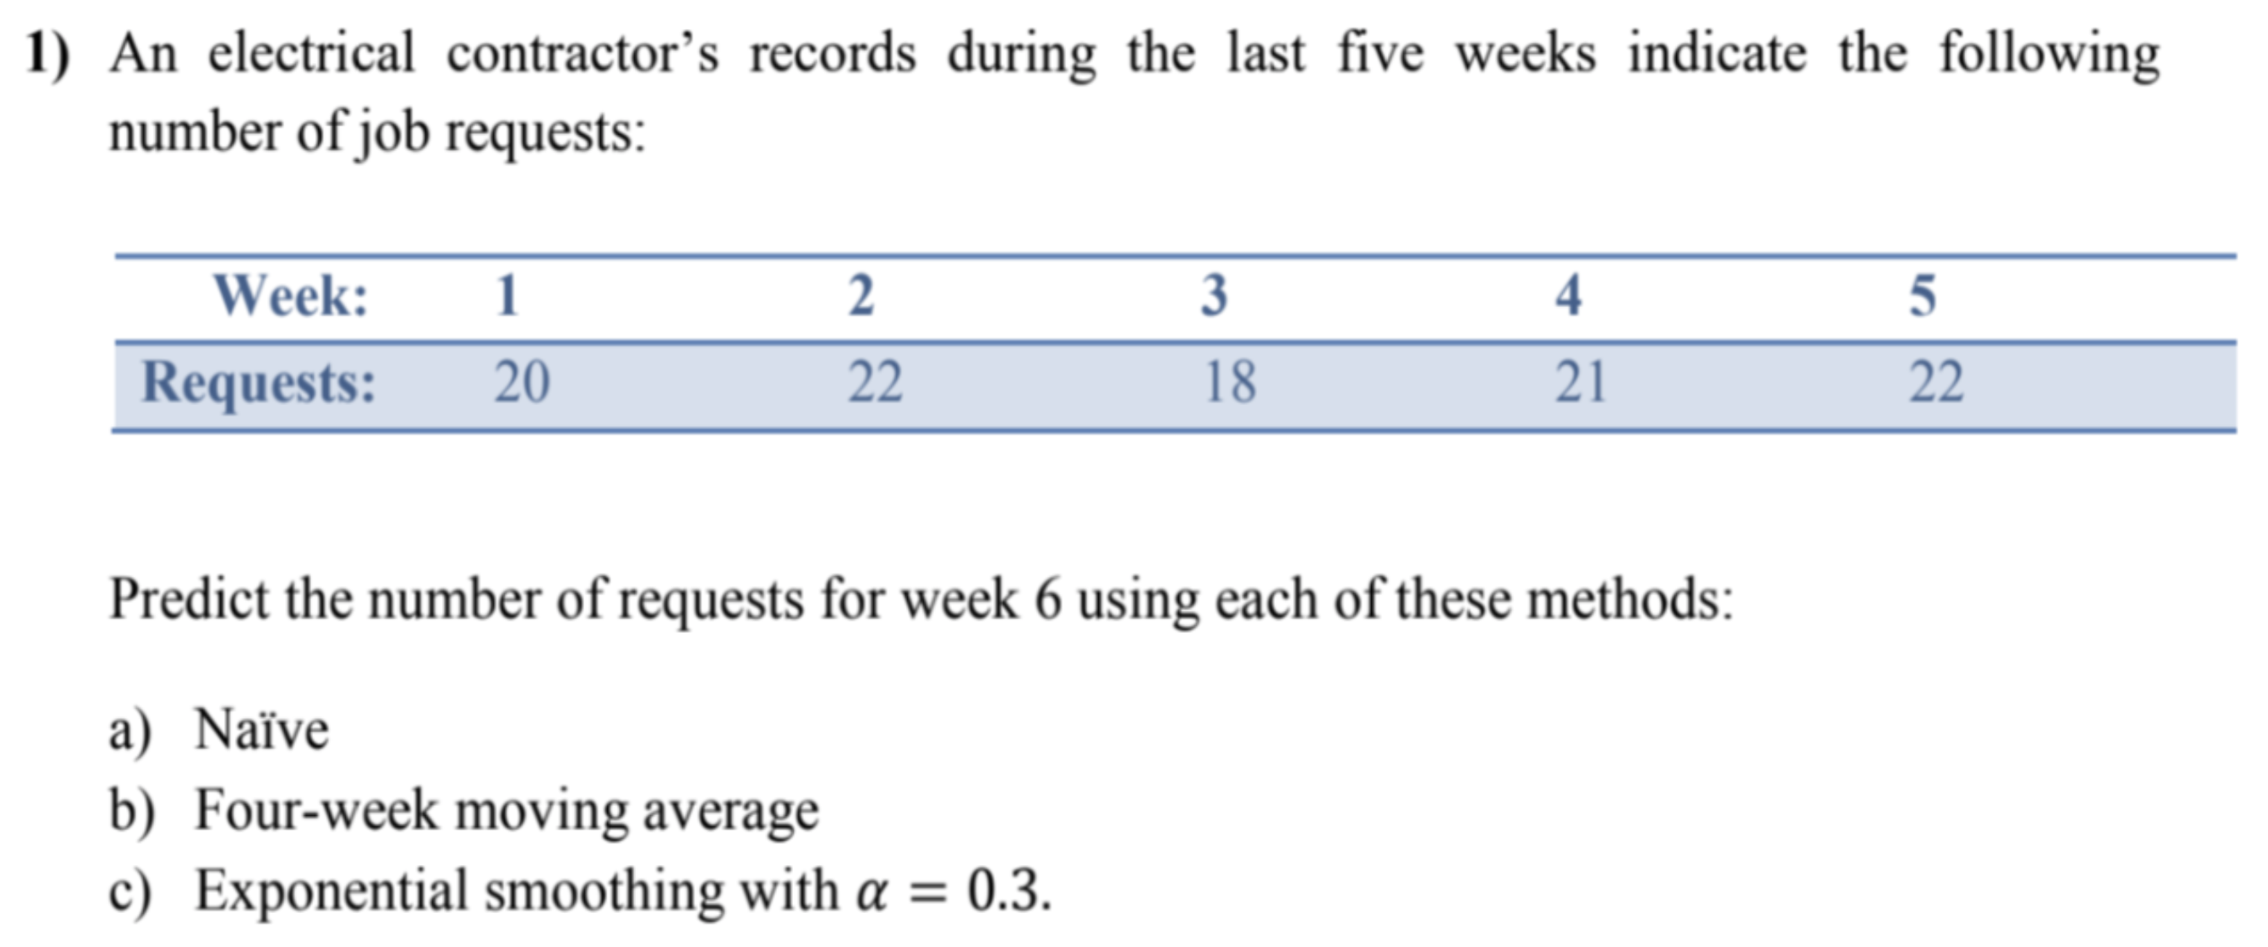

$22$

$\frac{22+18+21+22}{4}=20.75$

$F_{t}=F_{t-1}+α\left(A_{t-1}-F_{t-1}\right)$ $$F_{1}=20 \\ F_{2}=20+0.3\left(20-20\right)=20 \\ F_{3}=20+0.3\left(22-20\right)=20.6 \\ F_{4}=20.6+0.3\left(18-20.6\right)=19.82 \\ F_{5}=19.82+0.3\left(21-19.82\right)=20.17 \\ F_{6}=20.17+0.3\left(22-20.17\right)=20.72$$

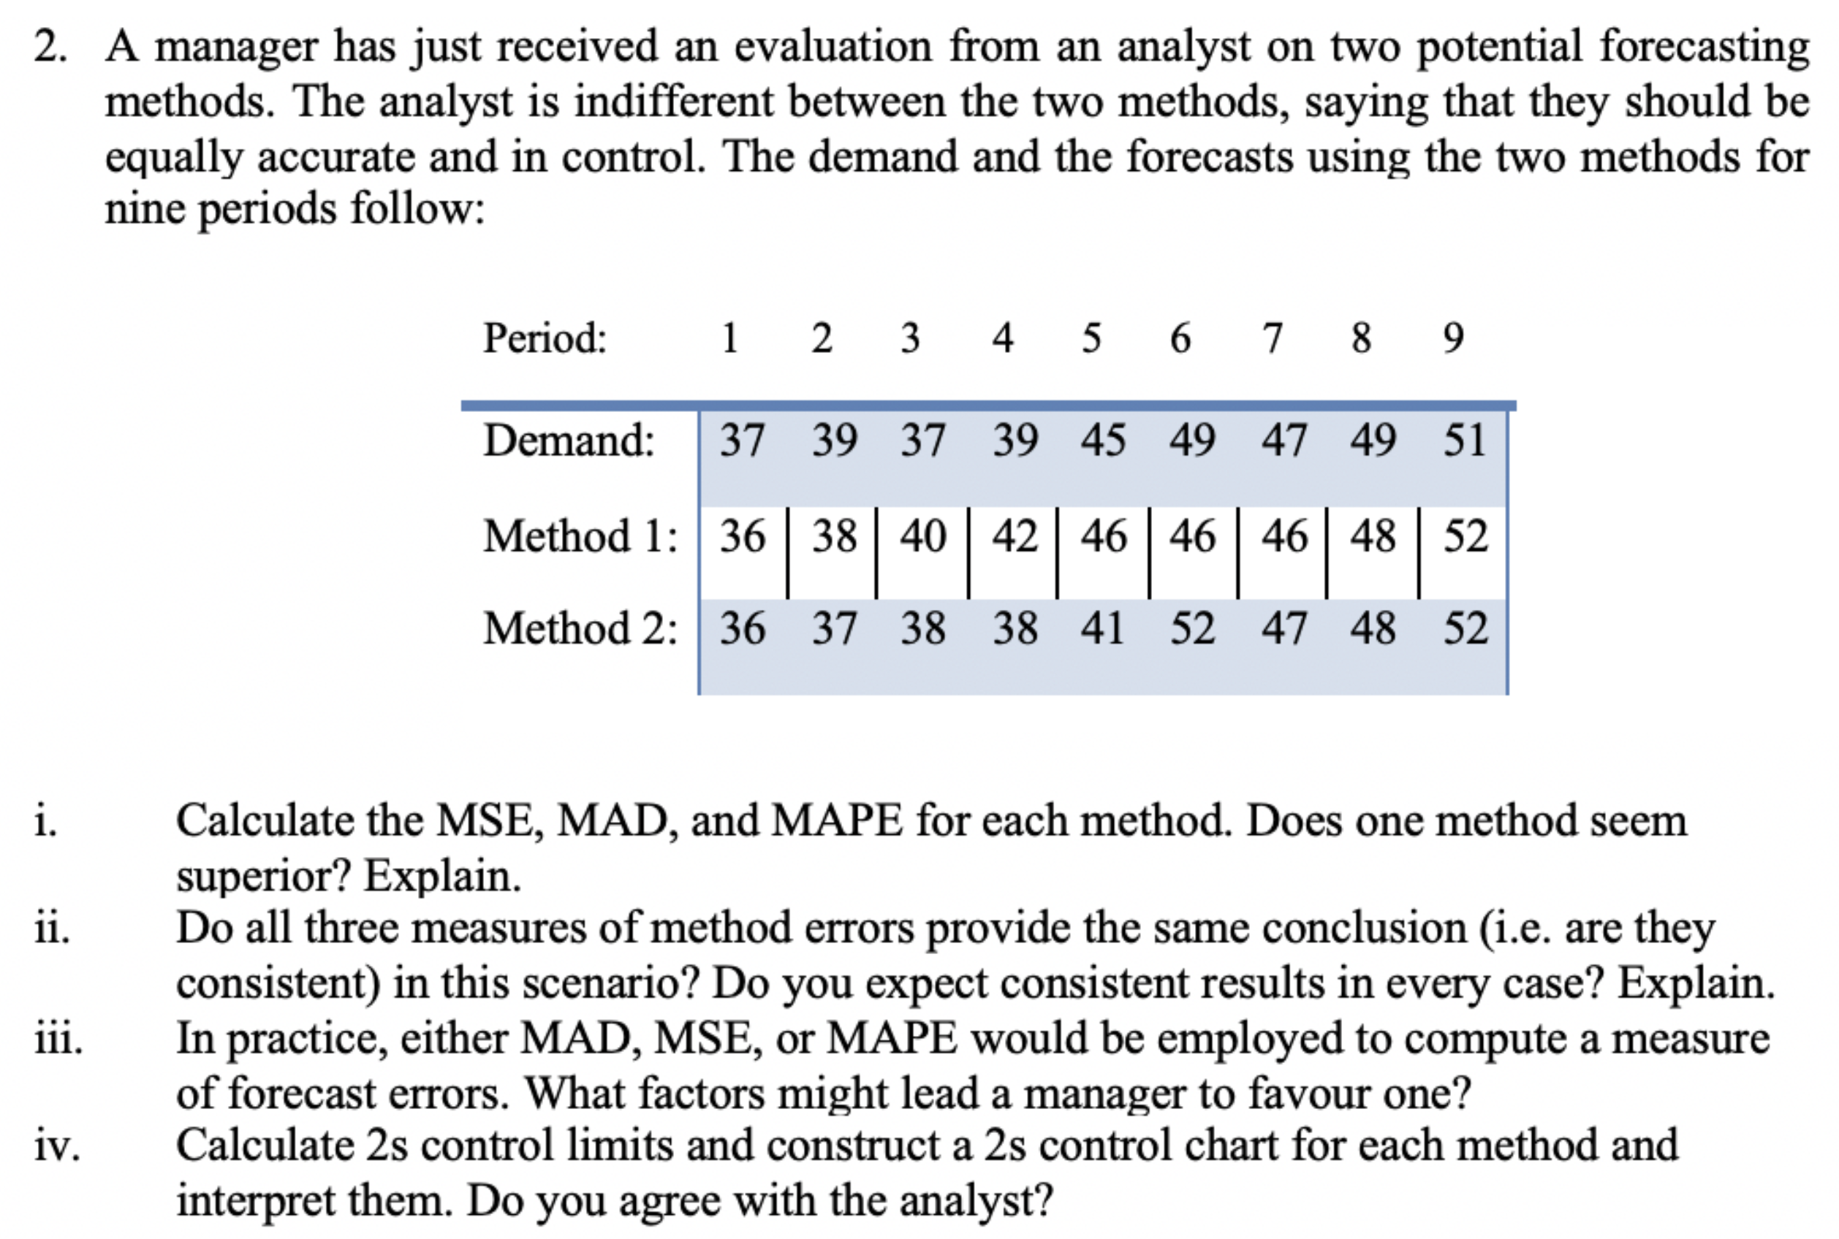

$MSE=\frac{∑{\left(A_{i}-F_{i}\right)}^{2}}{n}, MAD=\frac{∑\left|e\right|}{n}, MAPE=\frac{∑\left[\frac{\left|A_{i}-F_{i}\right|}{A_{i}}×100\right]}{n}$

|  |  |  |  |
| --- | --- | --- | --- |
| **Method** | **MSE** | **MAD** | **MAPE** |
| $$1$$ | $$3.7$$ | $$1.7$$ | 4.0 |
| $$2$$ | $$3.8$$ | $$16$$ | $$3.6$$ |

Both methods have similar $MSE, MAD, MAPE$, so neither is superior.

1. In this case, all calculations are similar, but may not be the same in other cases.
2. $MSE$ is more sensitive to large forecast errors, $MAD$ is easy to calculate, $MAPE$ is easy to understand.

$s_{1}=\sqrt{MSE_{1}}=\sqrt{3.7}=1.92, s_{2}=\sqrt{MSE_{2}}=\sqrt{3.78}=1.95$

Method 1: $2s$ control limits: $0±2s_{1}=0±2\left(1.92\right)⇒0±3.8$

Method 1: $2s$ control limits: $0±2s_{2}=0±2\left(1.95\right)⇒0±3.9$

Similar $2s$ control limits, however some errors outside limits.

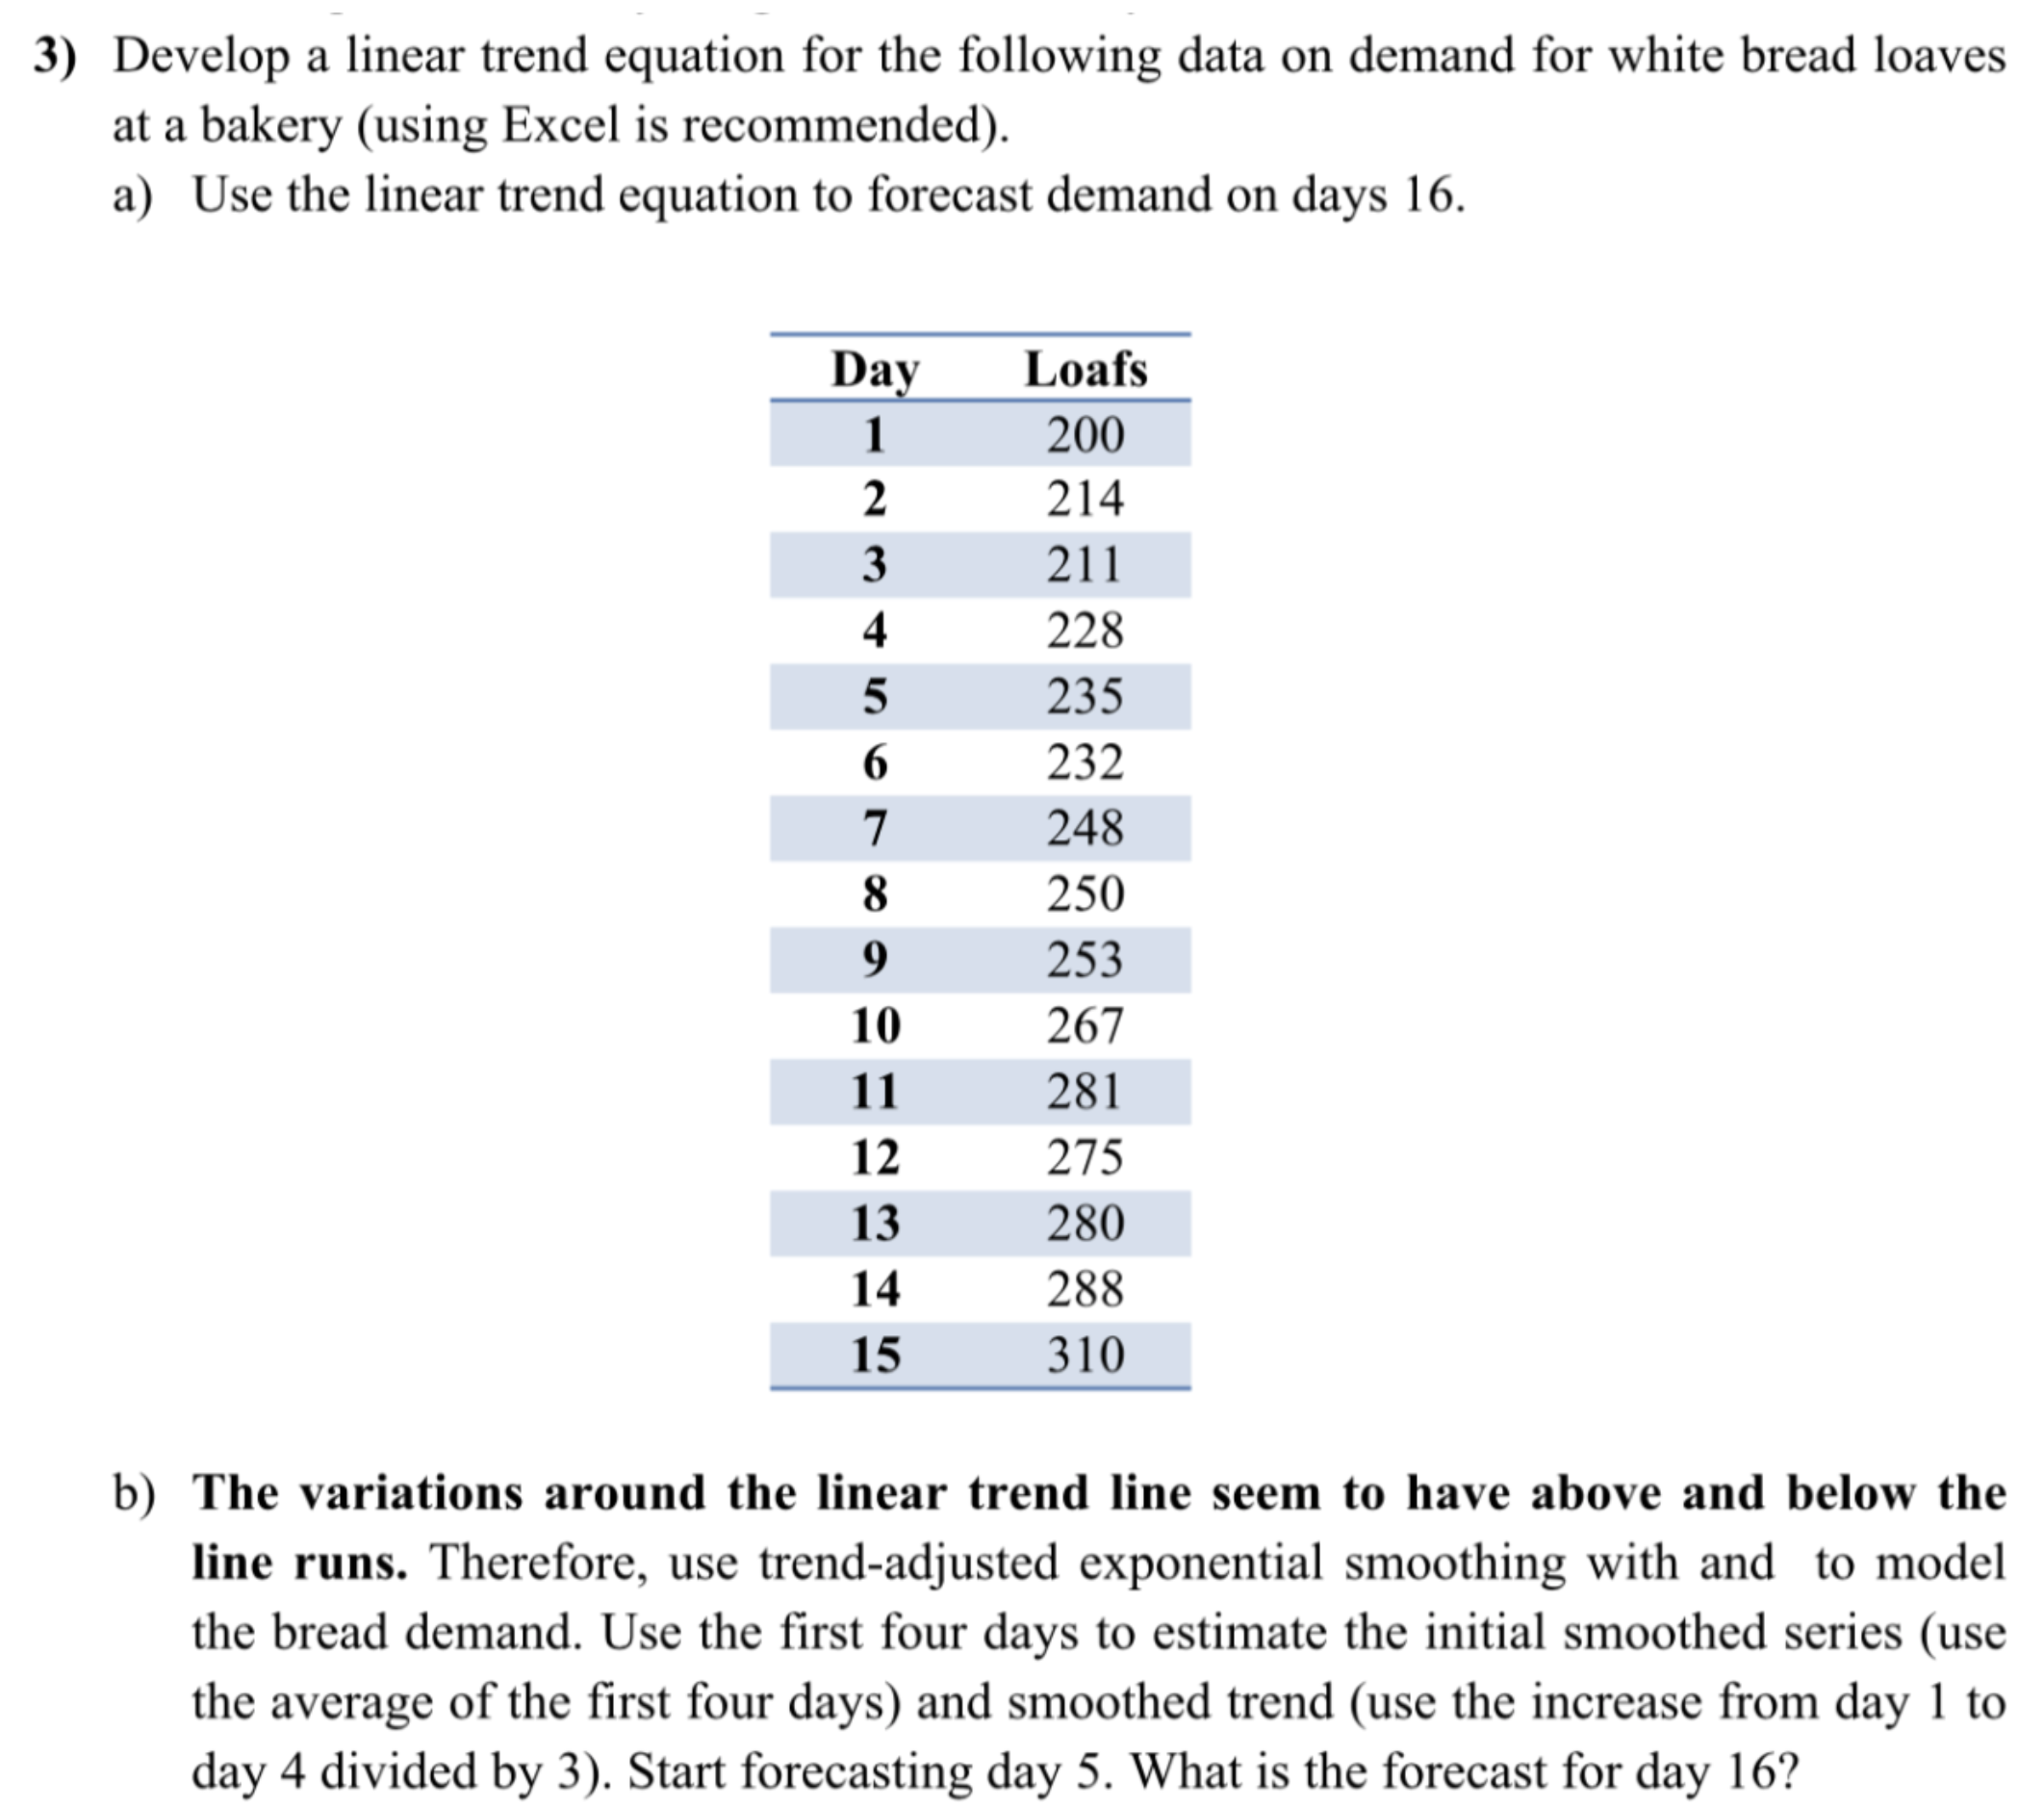

$α=0.3, β=0.2$

1. Equation of the trend: $y=7x+195.47$

$$D_{16}=7\left(16\right)+195.47⇒D_{16}=307.47$$

$S_{t}=TAF_{t}+α\left(A_{t}-TAF_{t}\right)$ $$T_{t}=T_{t-1}+β\left(S_{t}-S_{t-1}-T_{t-1}\right) \\ TAF_{t+1}=S_{t}+T_{t}$$

$$T_{4}=\frac{228-200}{3}=9.33, S_{4}=\frac{200+214+211+228}{4}=213.25$$
2. ­

Use above equations each time to get $TAF_{16}=S_{15}+T_{15}=303.53+7.64=311.17$.

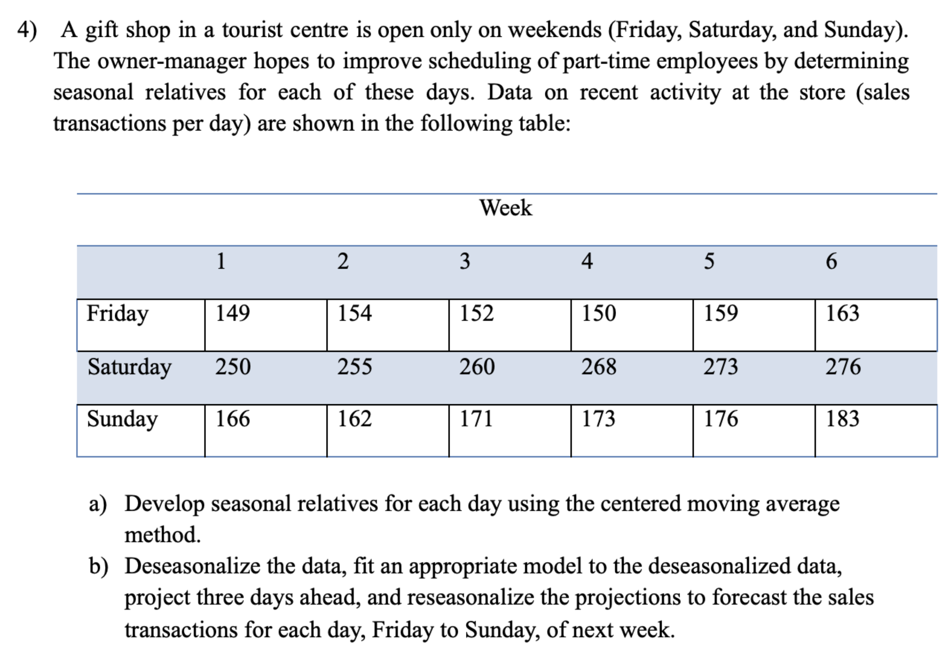

1. Seasonal relatives are shown as the values in the $adjusted$ row:

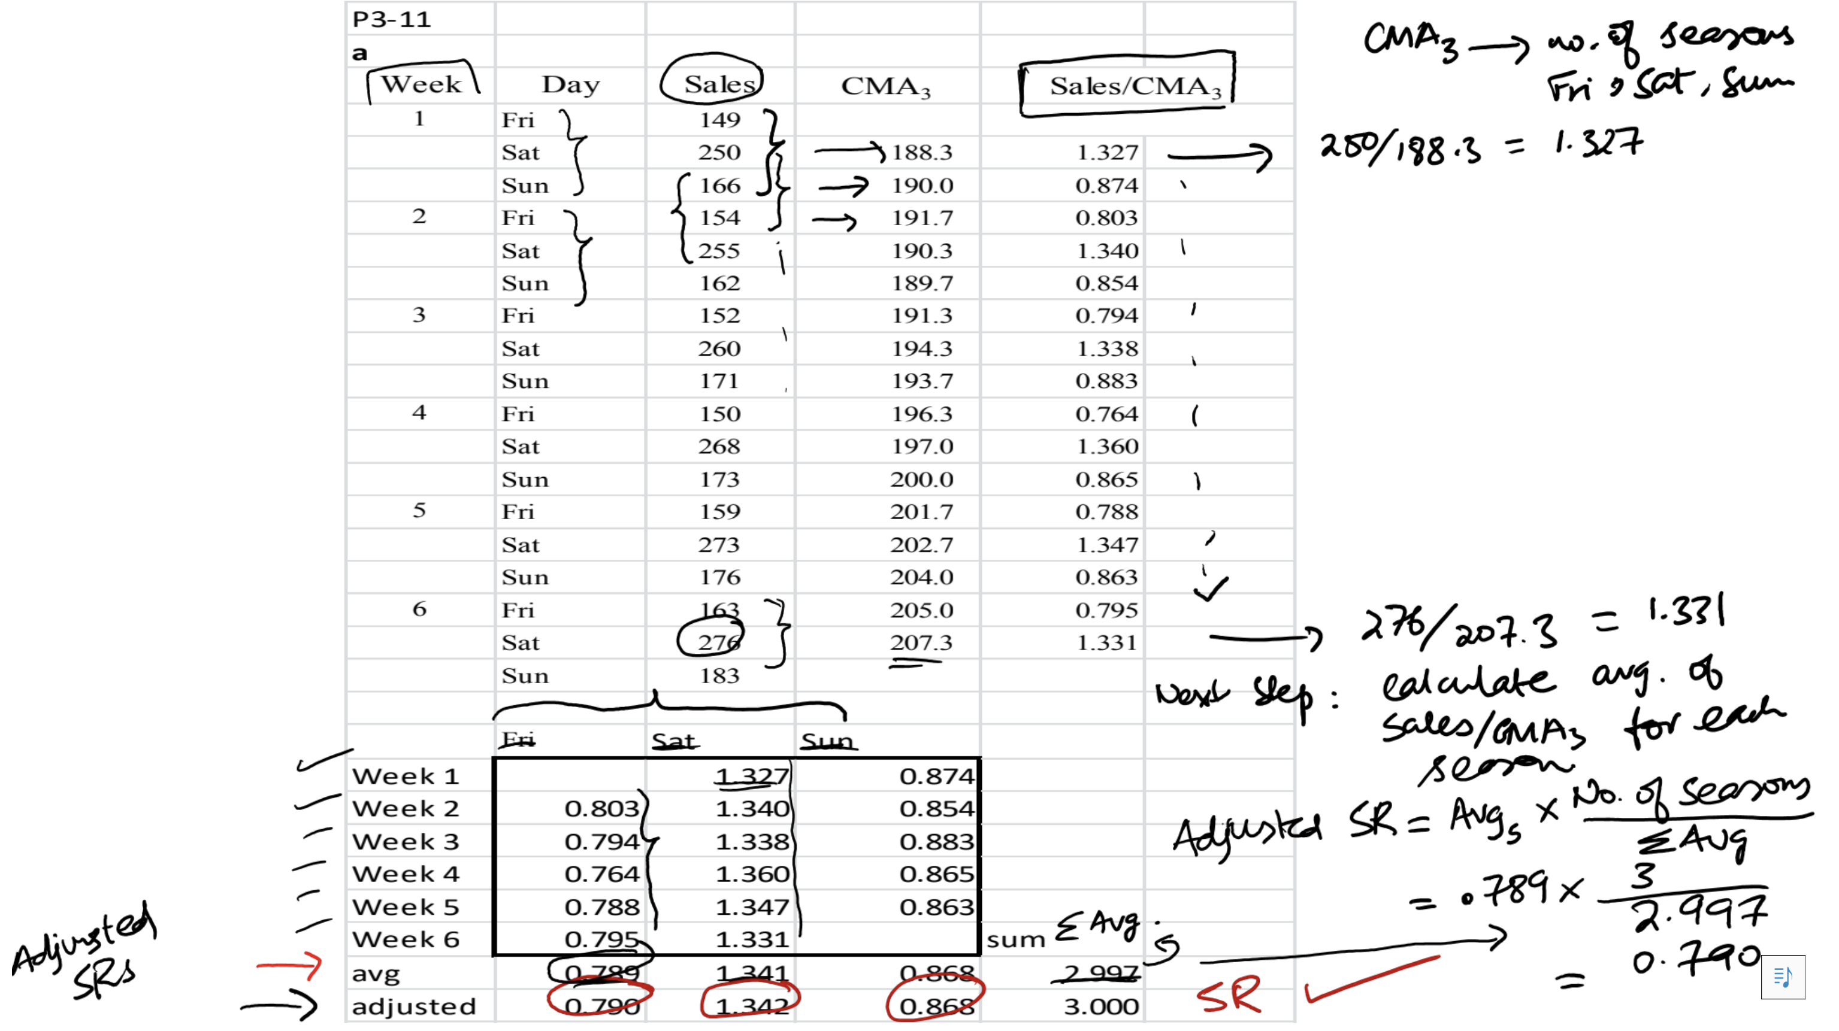

1. Deseasonalized data is shown as the values in the $Sales/SR$ column:

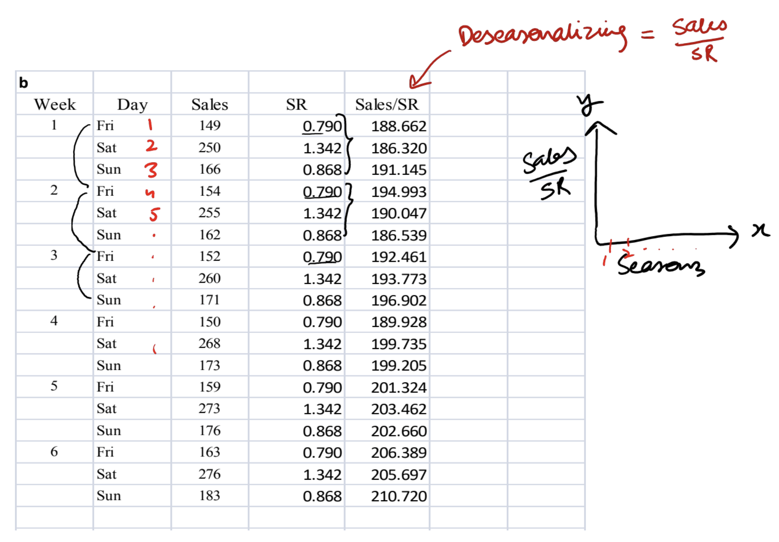

The model, projection, and reseasonalized data is shown below:

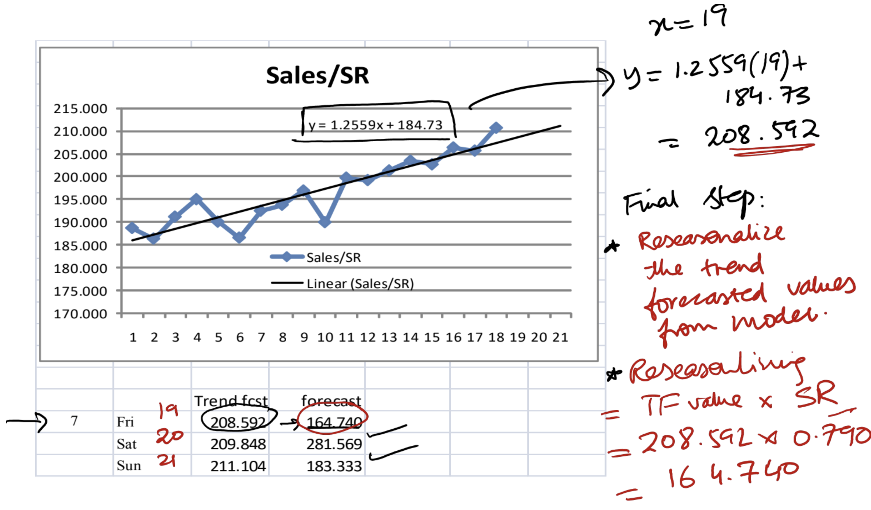

# Tutorial 2: Capacity Planning and Facility Layout

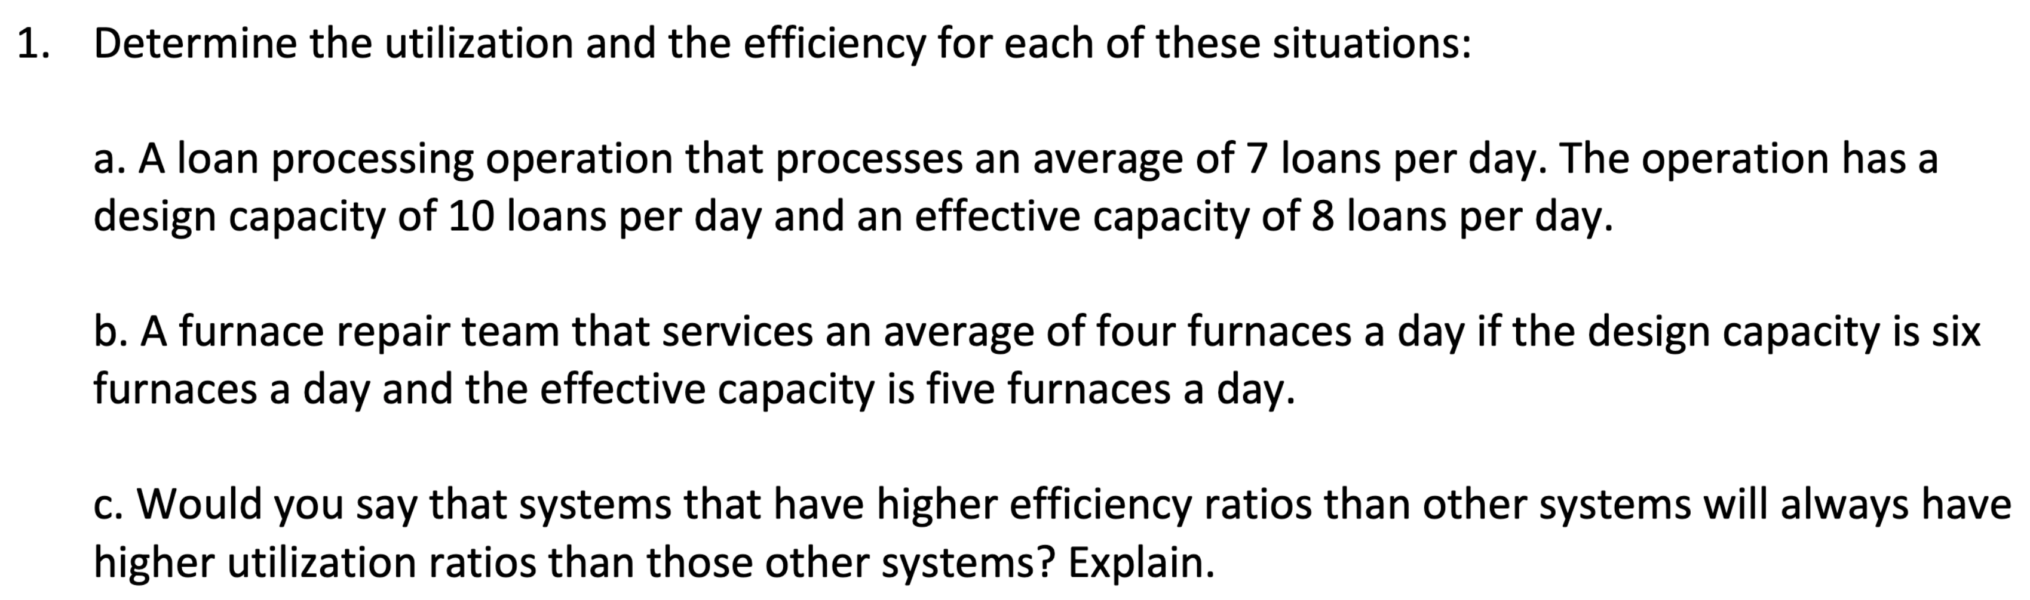

$actual output=7, design capacity=10, effective capacity=8$ $$utilization=\frac{actual output}{design capacity}=\frac{7}{10}=70\% \\ efficiency=\frac{actual output}{effective capacity}=\frac{7}{8}=87.5\%$$

$actual output=4, design capacity=6, effective capacity=5$ $$utilization=\frac{actual output}{design capacity}=\frac{4}{6}=66\% \\ efficiency=\frac{actual output}{effective capacity}=\frac{4}{5}=80\%$$

1. No because utilization depends on design capacity while efficiency depends on effective capacity.

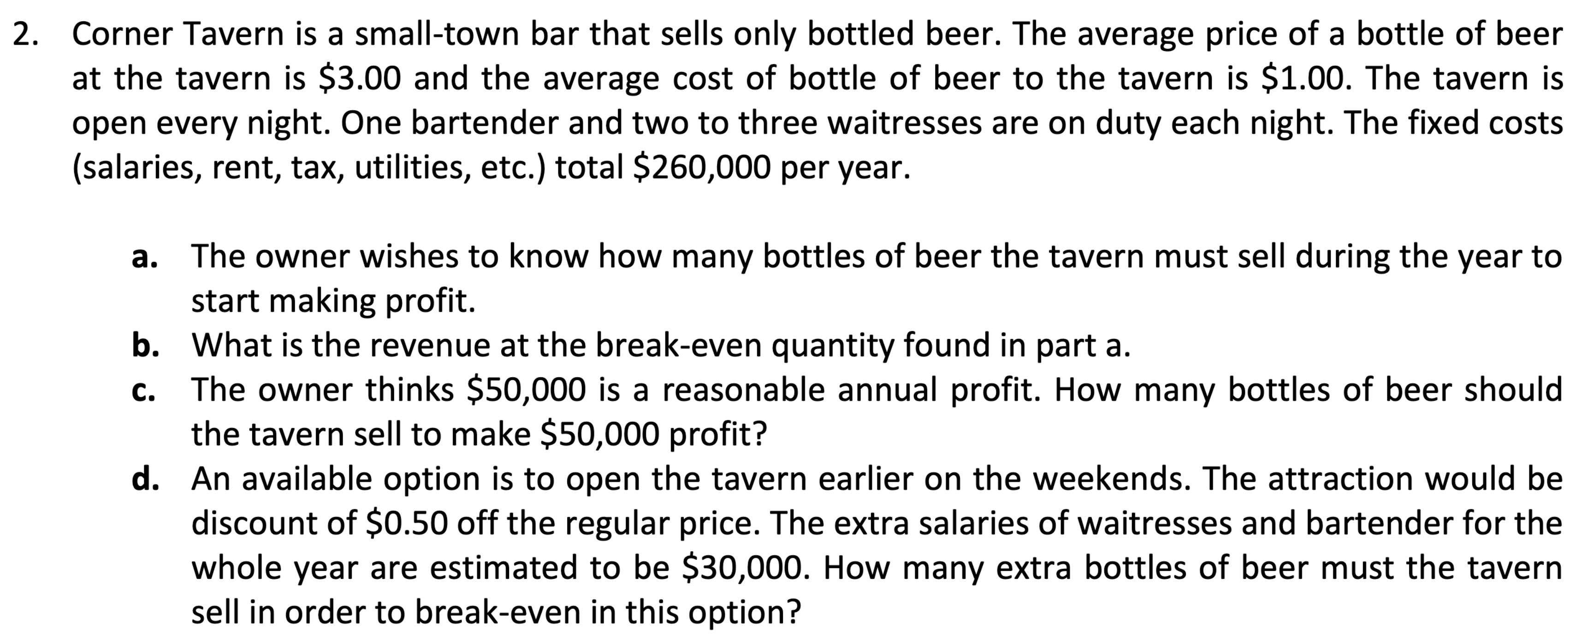

$average price \left(R\right)=\$3.00, average cost \left(v\right)=\$1.00, fixed cost \left(FC\right)=\$260,000$ $$Q_{BEP}=\frac{FC}{R-v}=\frac{260,000}{3-1}=130,000 bottles$$

$TR_{BEP}=Q_{BEP}⋅R=130,000⋅3=\$390,000$

$Q=\frac{P+FC}{R-v}=\frac{50,000+260,000}{3-1}=155,000 bottles$

$Q_{BEP}^{'}=\frac{FC^{'}}{R^{'}-v}=\frac{30,000}{2.5-1}=20,000 bottles$

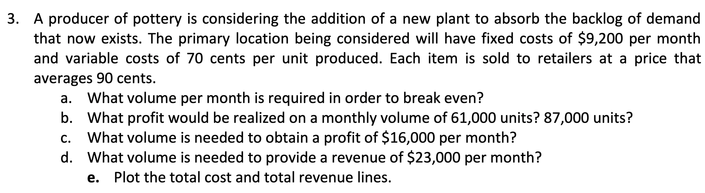

$FC=\$9,200, v=70 cents→\$0.7, R=90 cents→\$0.9$ $$Q_{BEP}=\frac{FC}{R-v}=\frac{9,200}{0.9-0.7}=46,000 units$$

$P=Q\left(R-v\right)-FC$ $$P_{1}=61,000\left(0.9-0.7\right)-9,200=\$3,000$$

$$P_{2}=87,000\left(0.9-0.7\right)-9,200=\$8,200$$

$Q=\frac{P+FC}{R-v}=\frac{16,000+9,200}{0.9-0.7}=126,000 units$

$Q=\frac{P+FC}{R-v}=\frac{23,000+9,200}{0.9-0.7}=161,000 units$

1. Plot of $total cost (TC)=0.7Q+10,000$ and $total revenue (TR)=0.9Q$ lines:

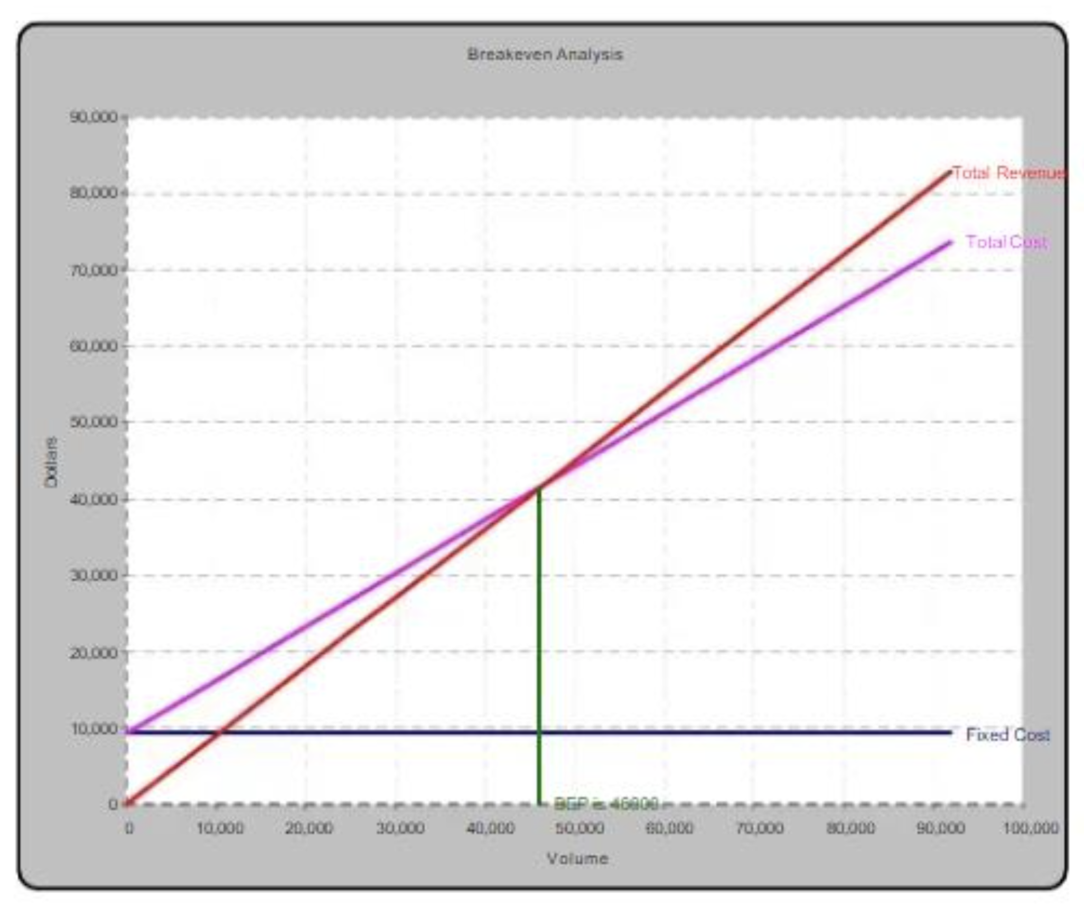

# Tutorial 3: Process Design and Facility Layout

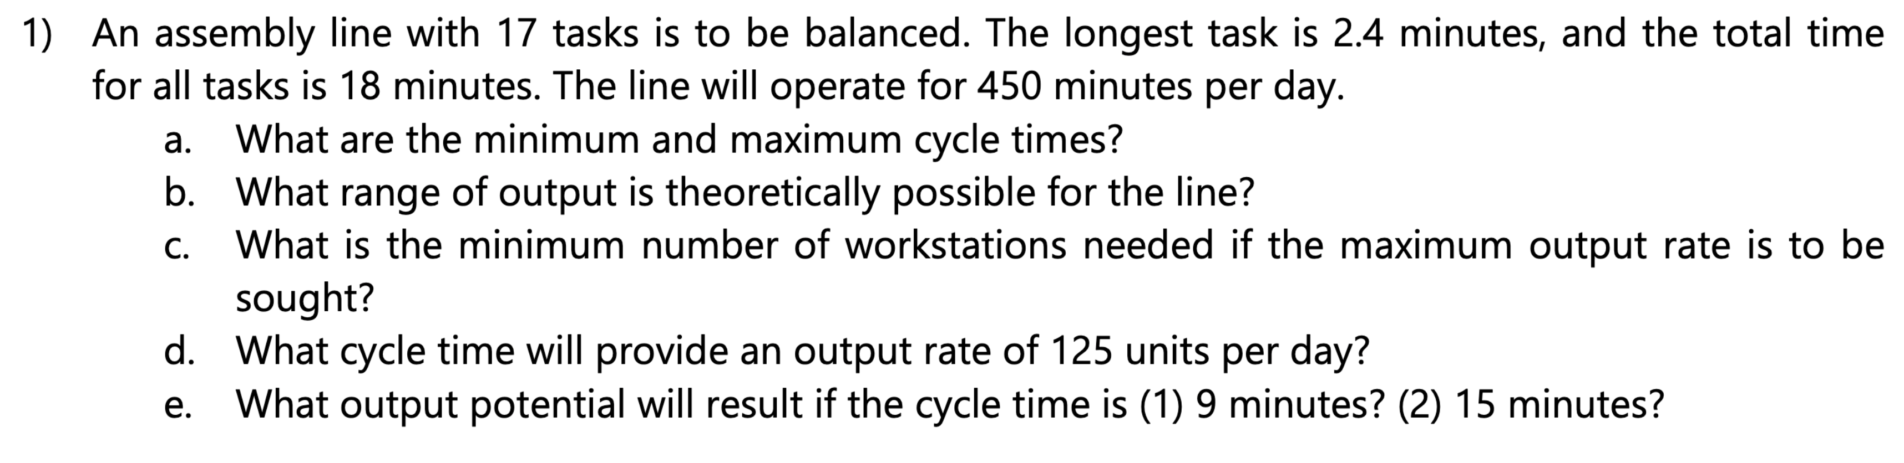

$OT=450 minutes$

$Minimum cycle time=length of longest task=2.4 minutes$

$Maximum cycle time=\sum{task times}=18 minutes$

$At 2.4 min:\frac{450}{2.4}=187.5 units$

$At 18 min:\frac{450}{18}=25 units$

$N=\frac{D×\sum{t}}{OT}=\frac{187.5×18}{450}=7.5→8$

1. $Output=\frac{OT}{CT}$, Solving for $CT$: $CT=\frac{450}{125}=3.6 minutes/cycle$
2. Potential output:

$\left(1\right) CT=9 min→\frac{OT}{CT}=\frac{450}{9}=50 units$

$\left(2\right) CT=15 min→\frac{450}{15}=30 units$

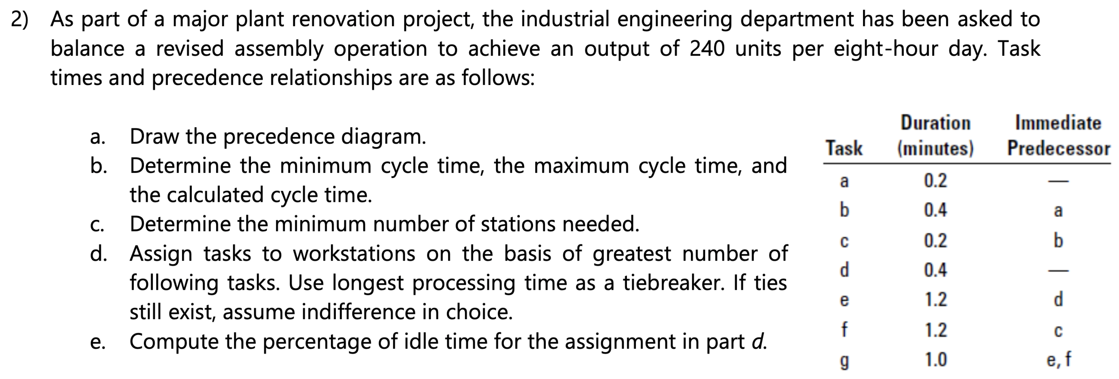

1. Precedence diagram:

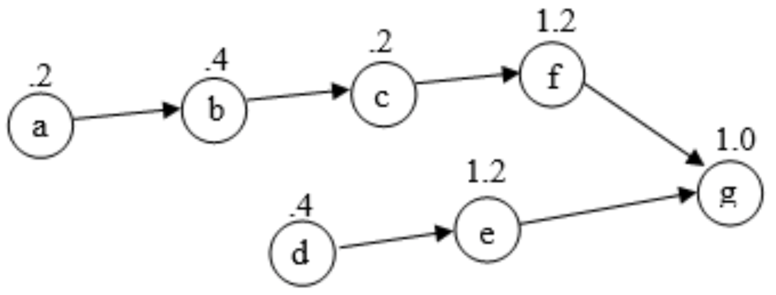

$Minimum cycle time=maximum task time=1.2 minutes$

$Maximum cycle time=0.2+0.4+0.2+0.4+1.2+1.2+1.0=4.6 minutes$

$CT=\frac{OT}{output}=\frac{480 min/day}{240 units/day}=2 minutes$

$N=\frac{\sum{t}}{CT}=\frac{4.6}{2.0}=2.3→3 stations$

1. Assign tasks to workstations:

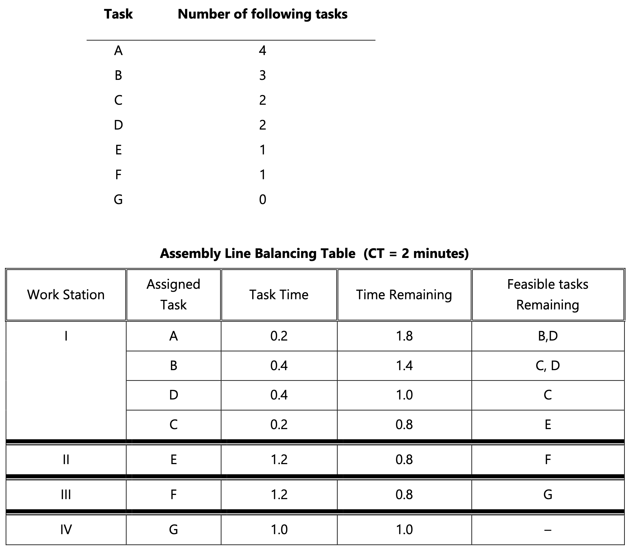

$Idle percent=\frac{0.8+0.8+0.8+1.0}{\left(4\right)\left(2\right)}=\frac{3.4}{8.0}=42.5\%$

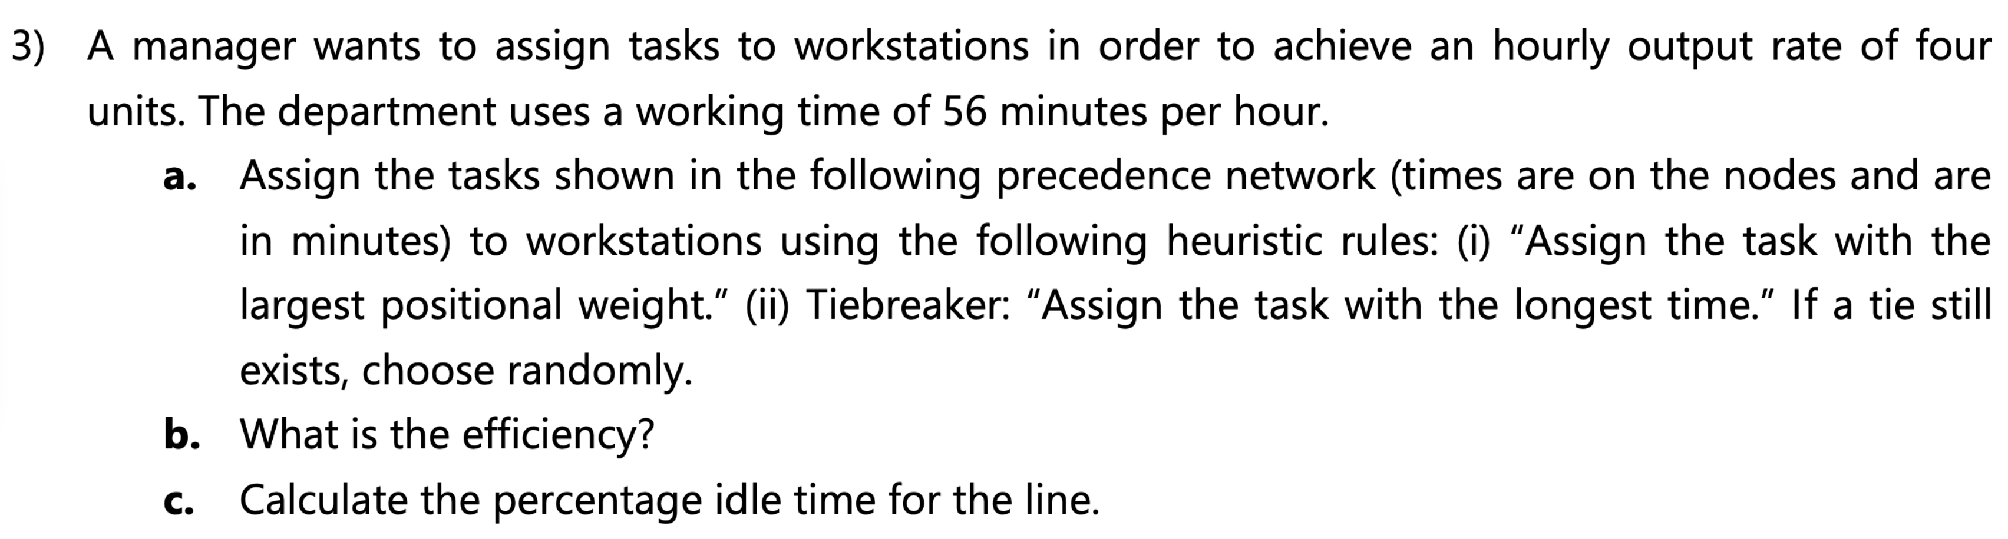

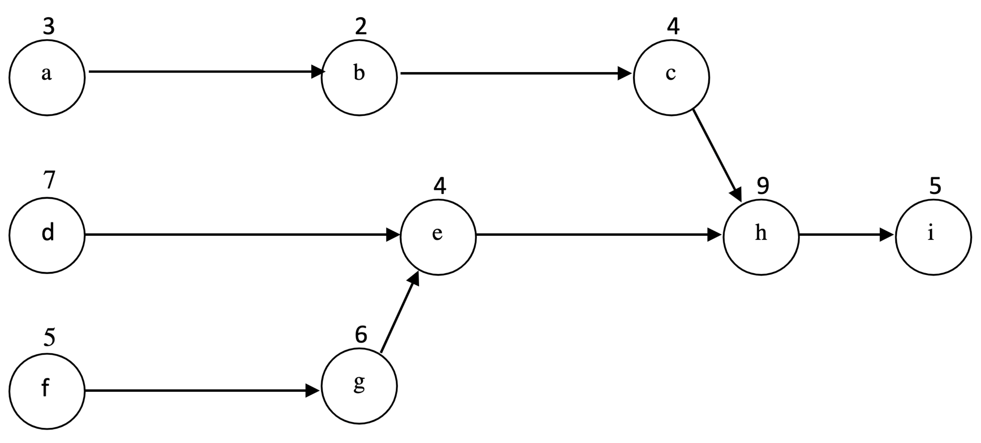

$Desired output=4 units/hour$

$Operating time=56 minutes/hour$

$CT=\frac{Operating time}{Desired output}=\frac{56 minutes/hour}{4 units/hour}=14 minutes/unit$

$N_{min}=\frac{\sum{t}}{CT}=\frac{3+2+4+7+4+5+6+9+5}{14}=3.21→4 workstations$

Positional weights:

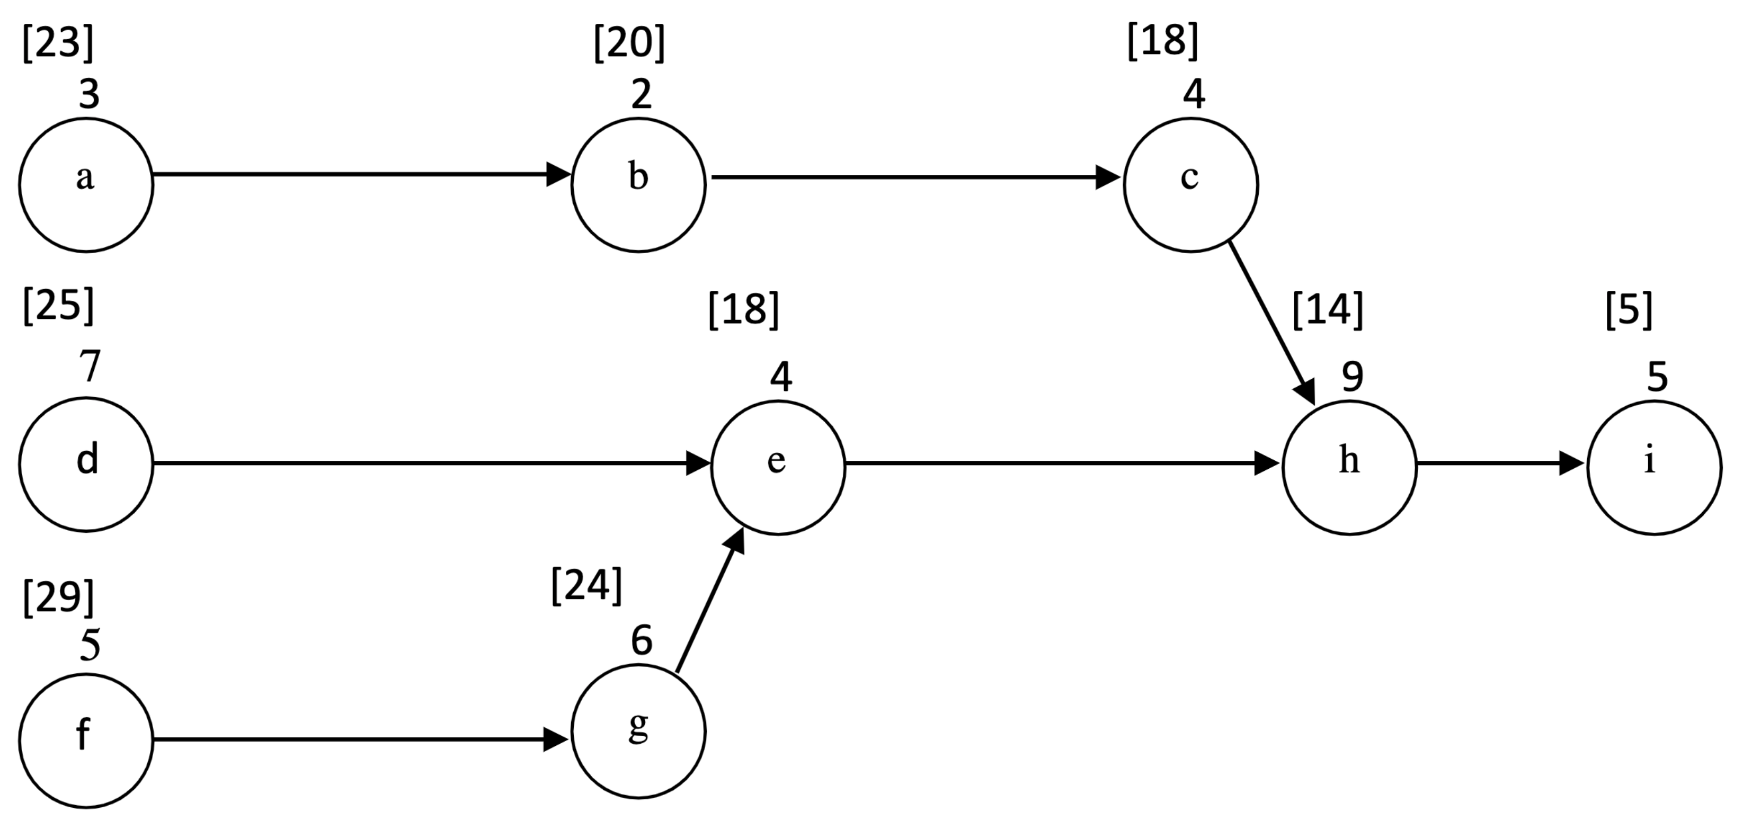

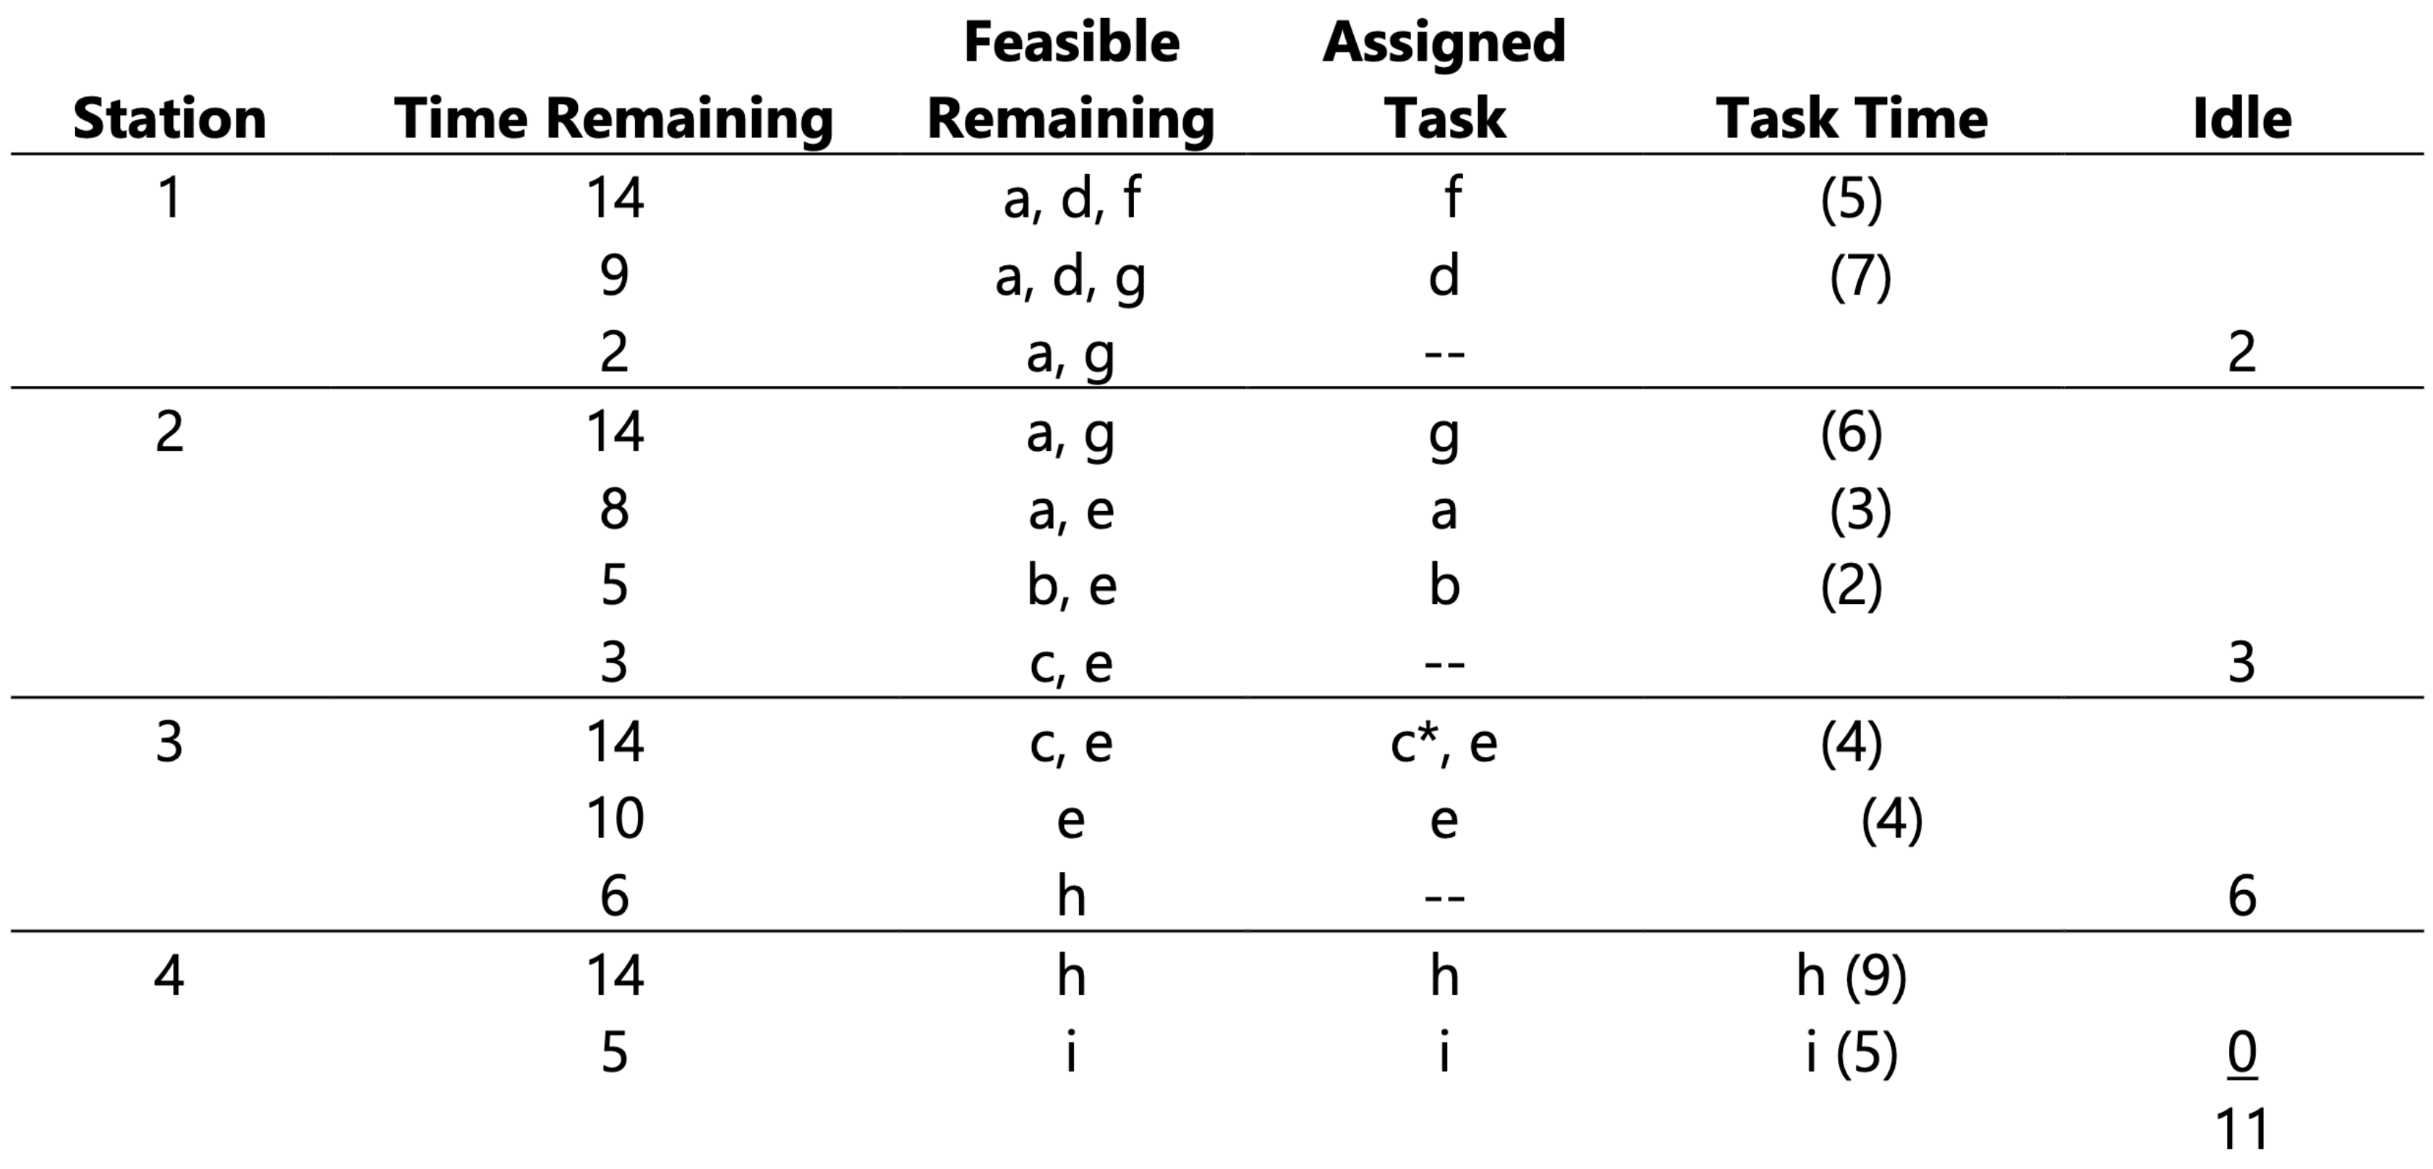

4. Fixed-Position Layout: Product or project remains stationary, and workers, materials, and equipment are moved as needed.

5. Cycle Time: The maximum time allowed at each workstation to complete its set of tasks on a unit.

# Tutorial 4: Quality Management and Statistical Control

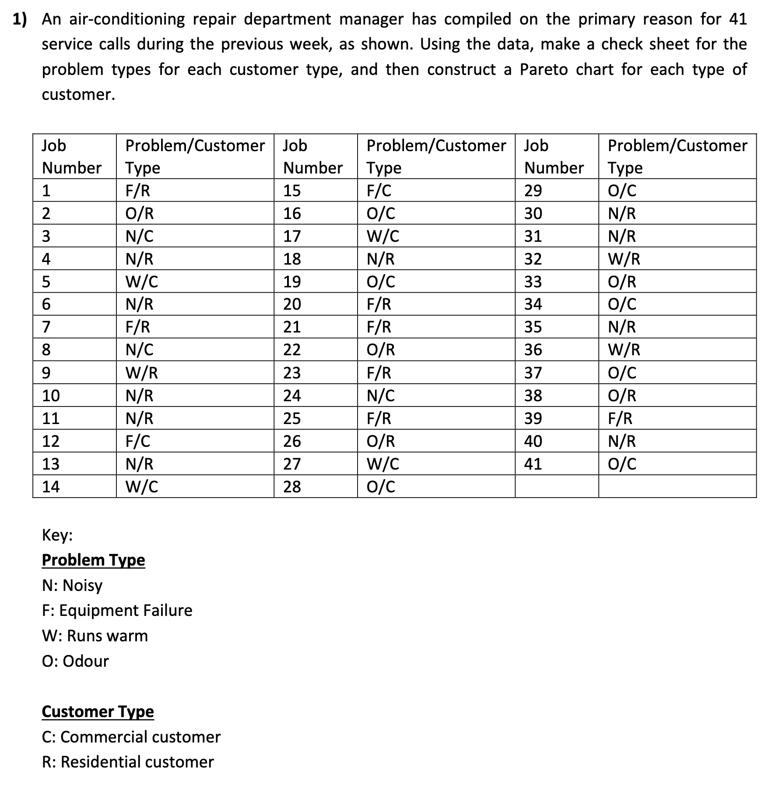

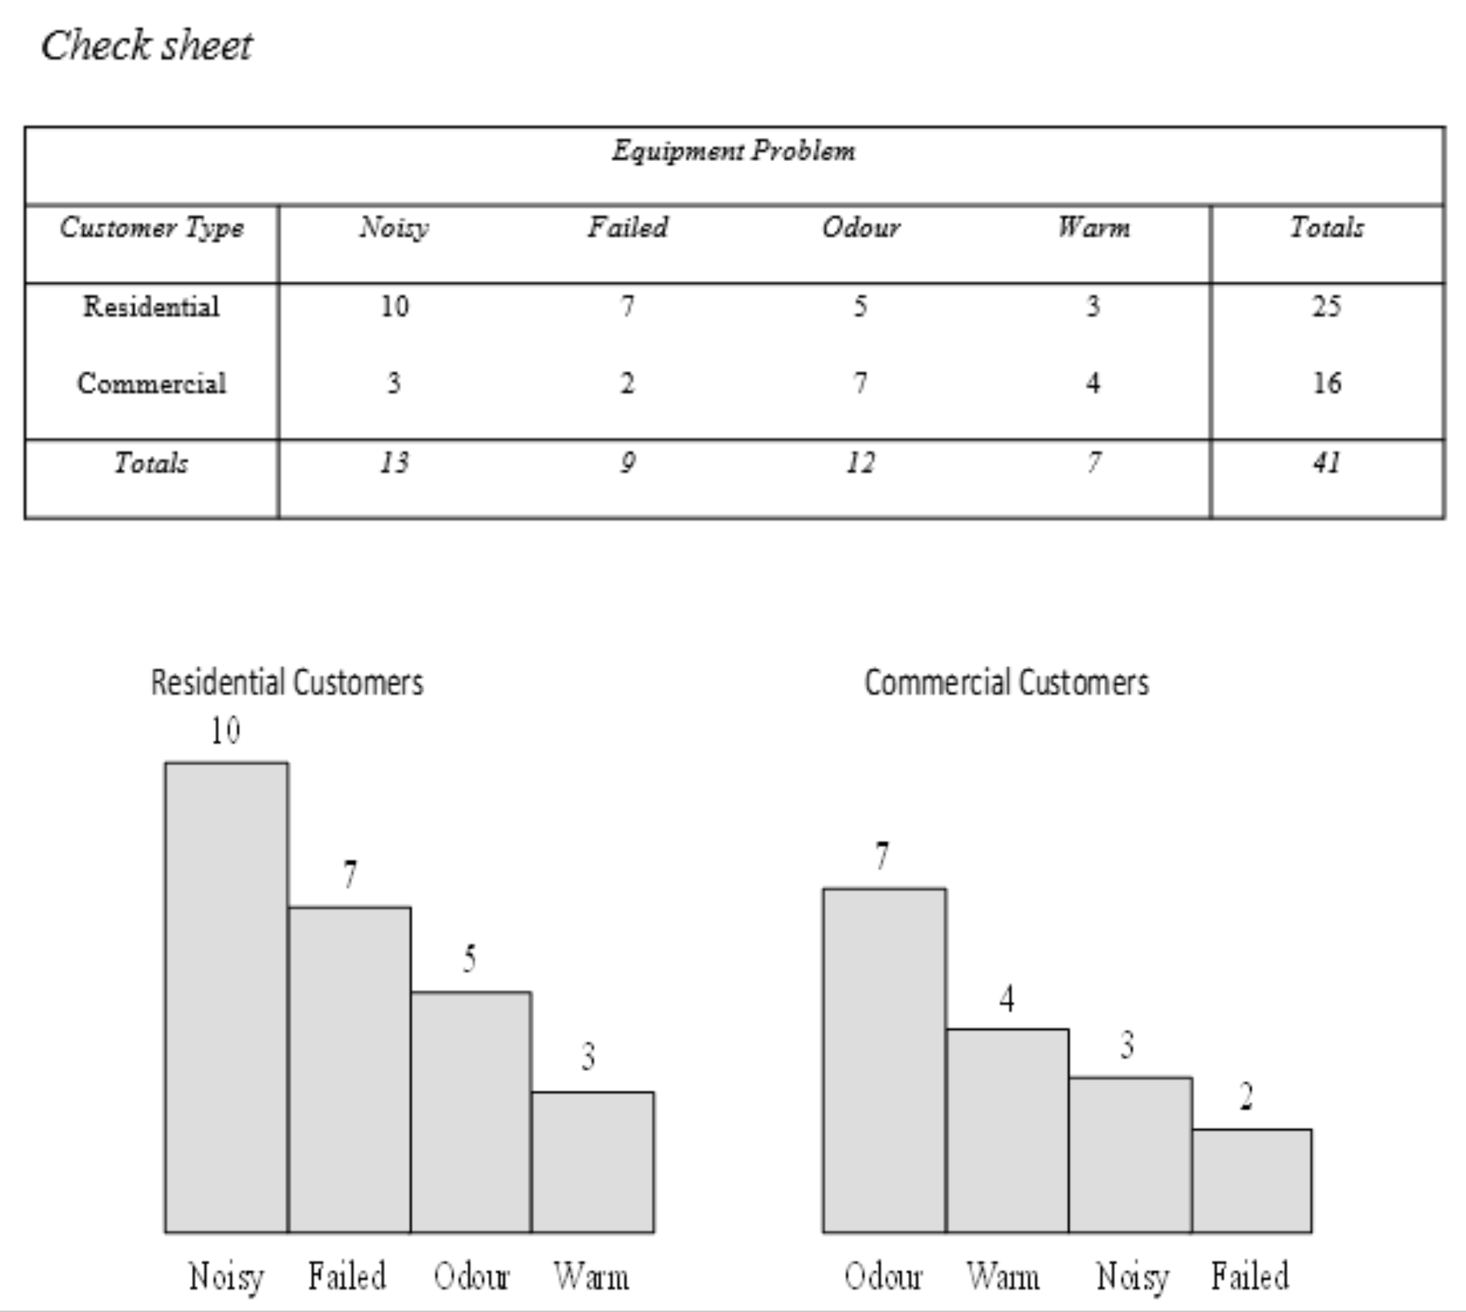

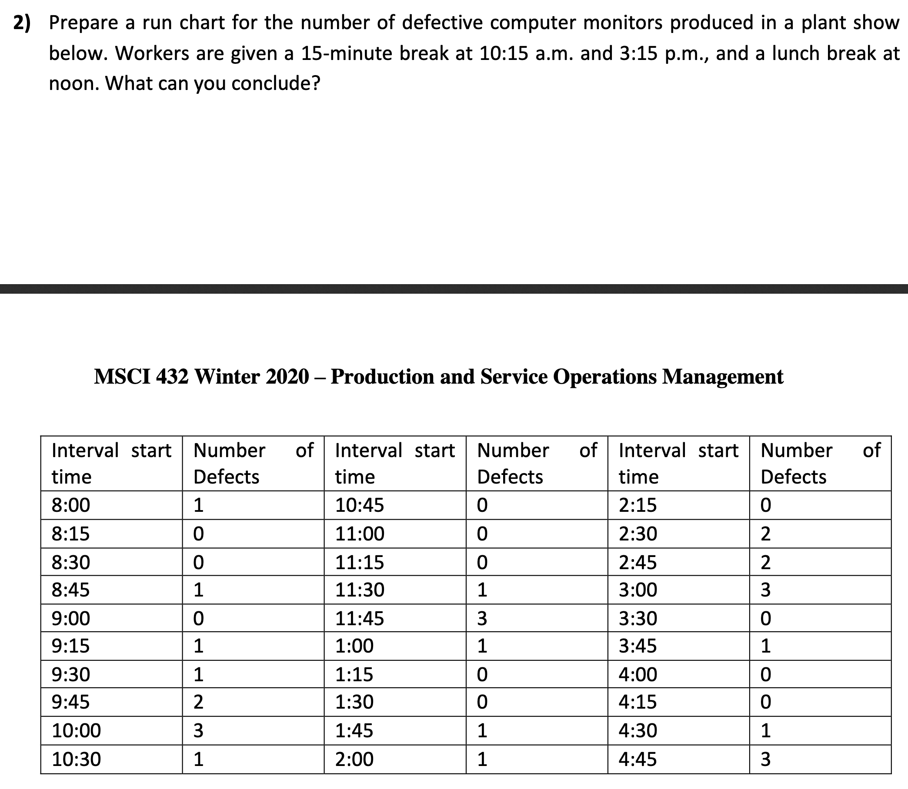

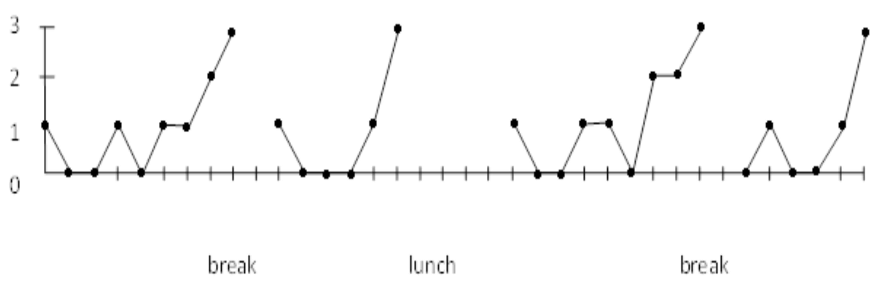

Increasing pattern of errors just before the break times, lunch, and the end of the shift.

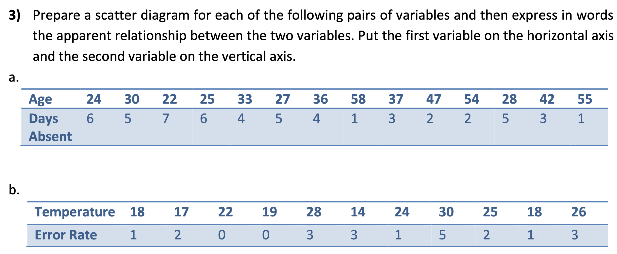

1. Scatter diagram for $a$:

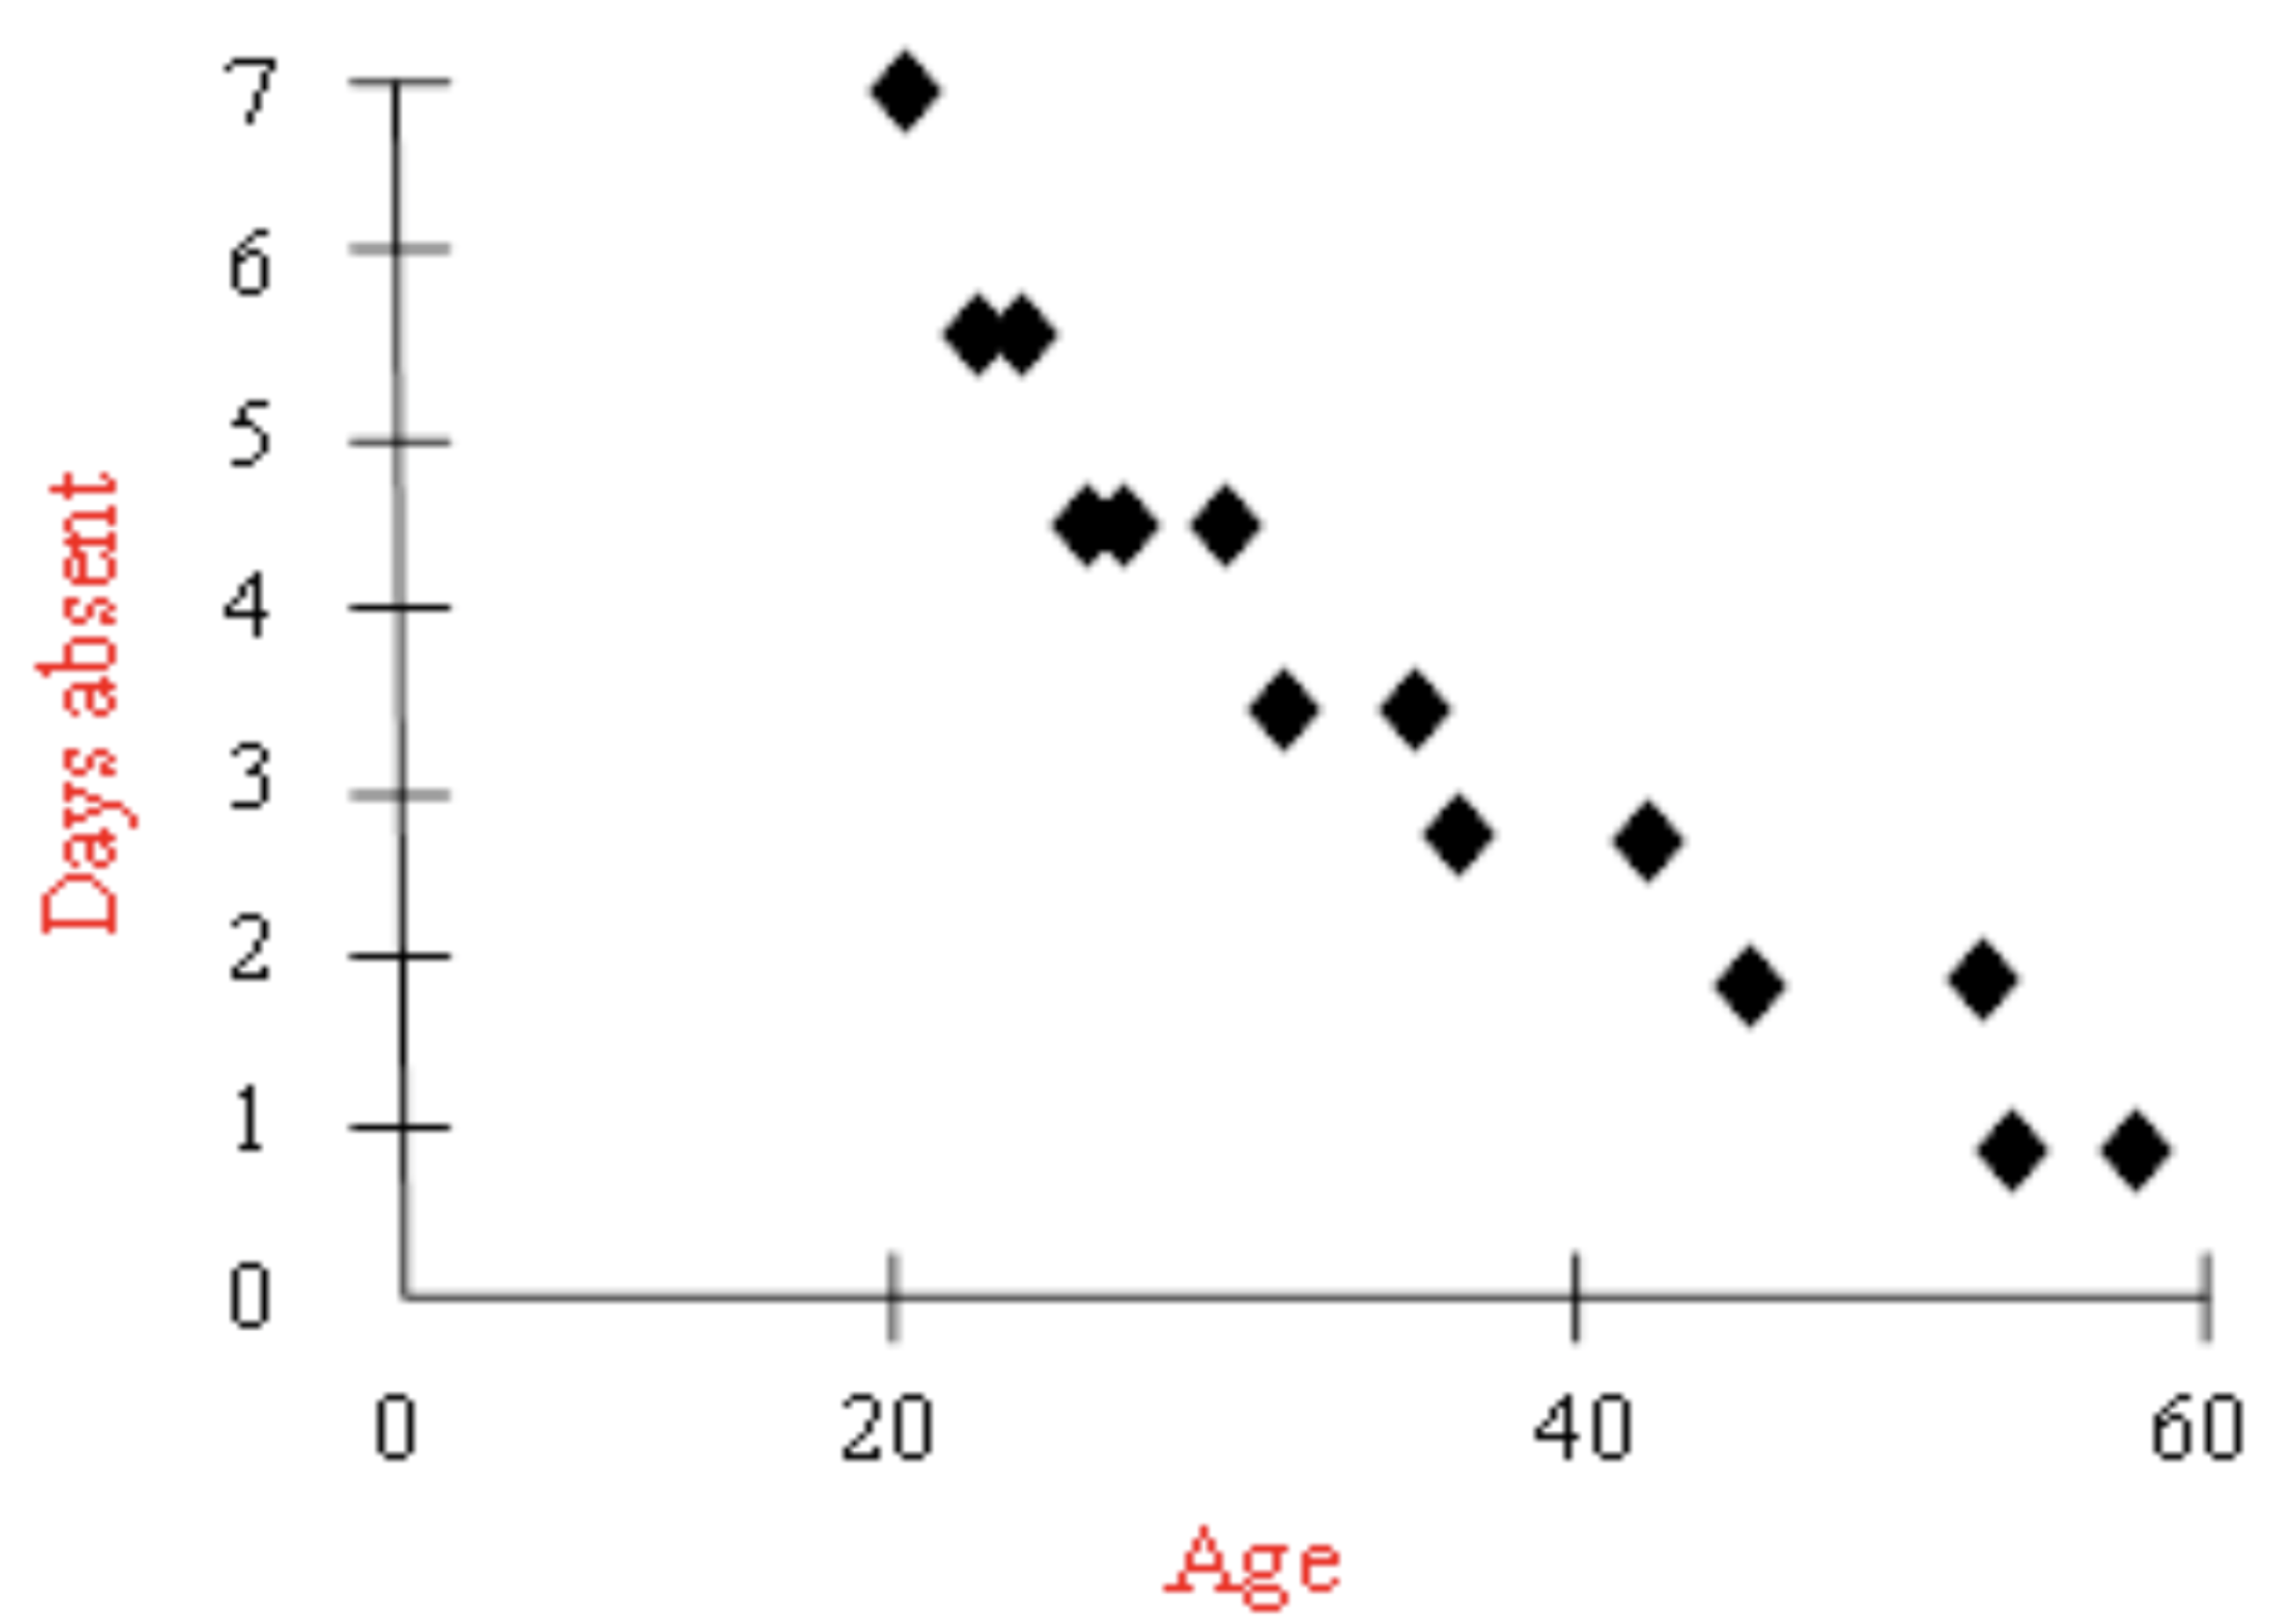

Age and days absent are inversely related. Older employees missed fewer days.

1. Scatter diagram for $b$:

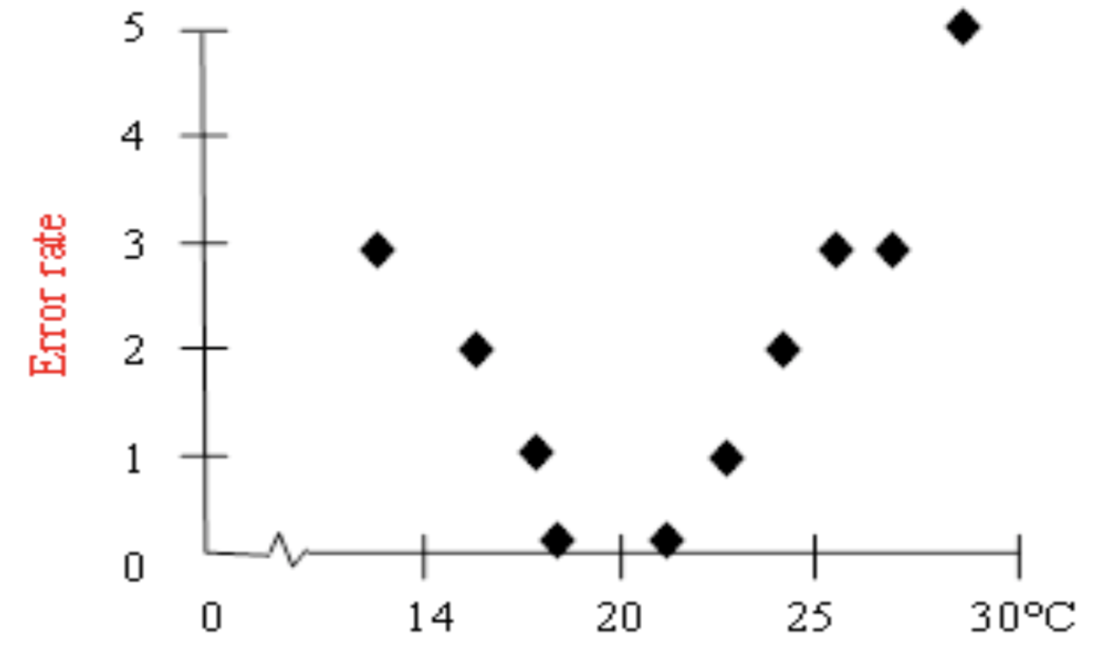

Error rate is non-linearly related to temperature. It increases in colder or hotter temperatures. The lowest error rate occurs around .



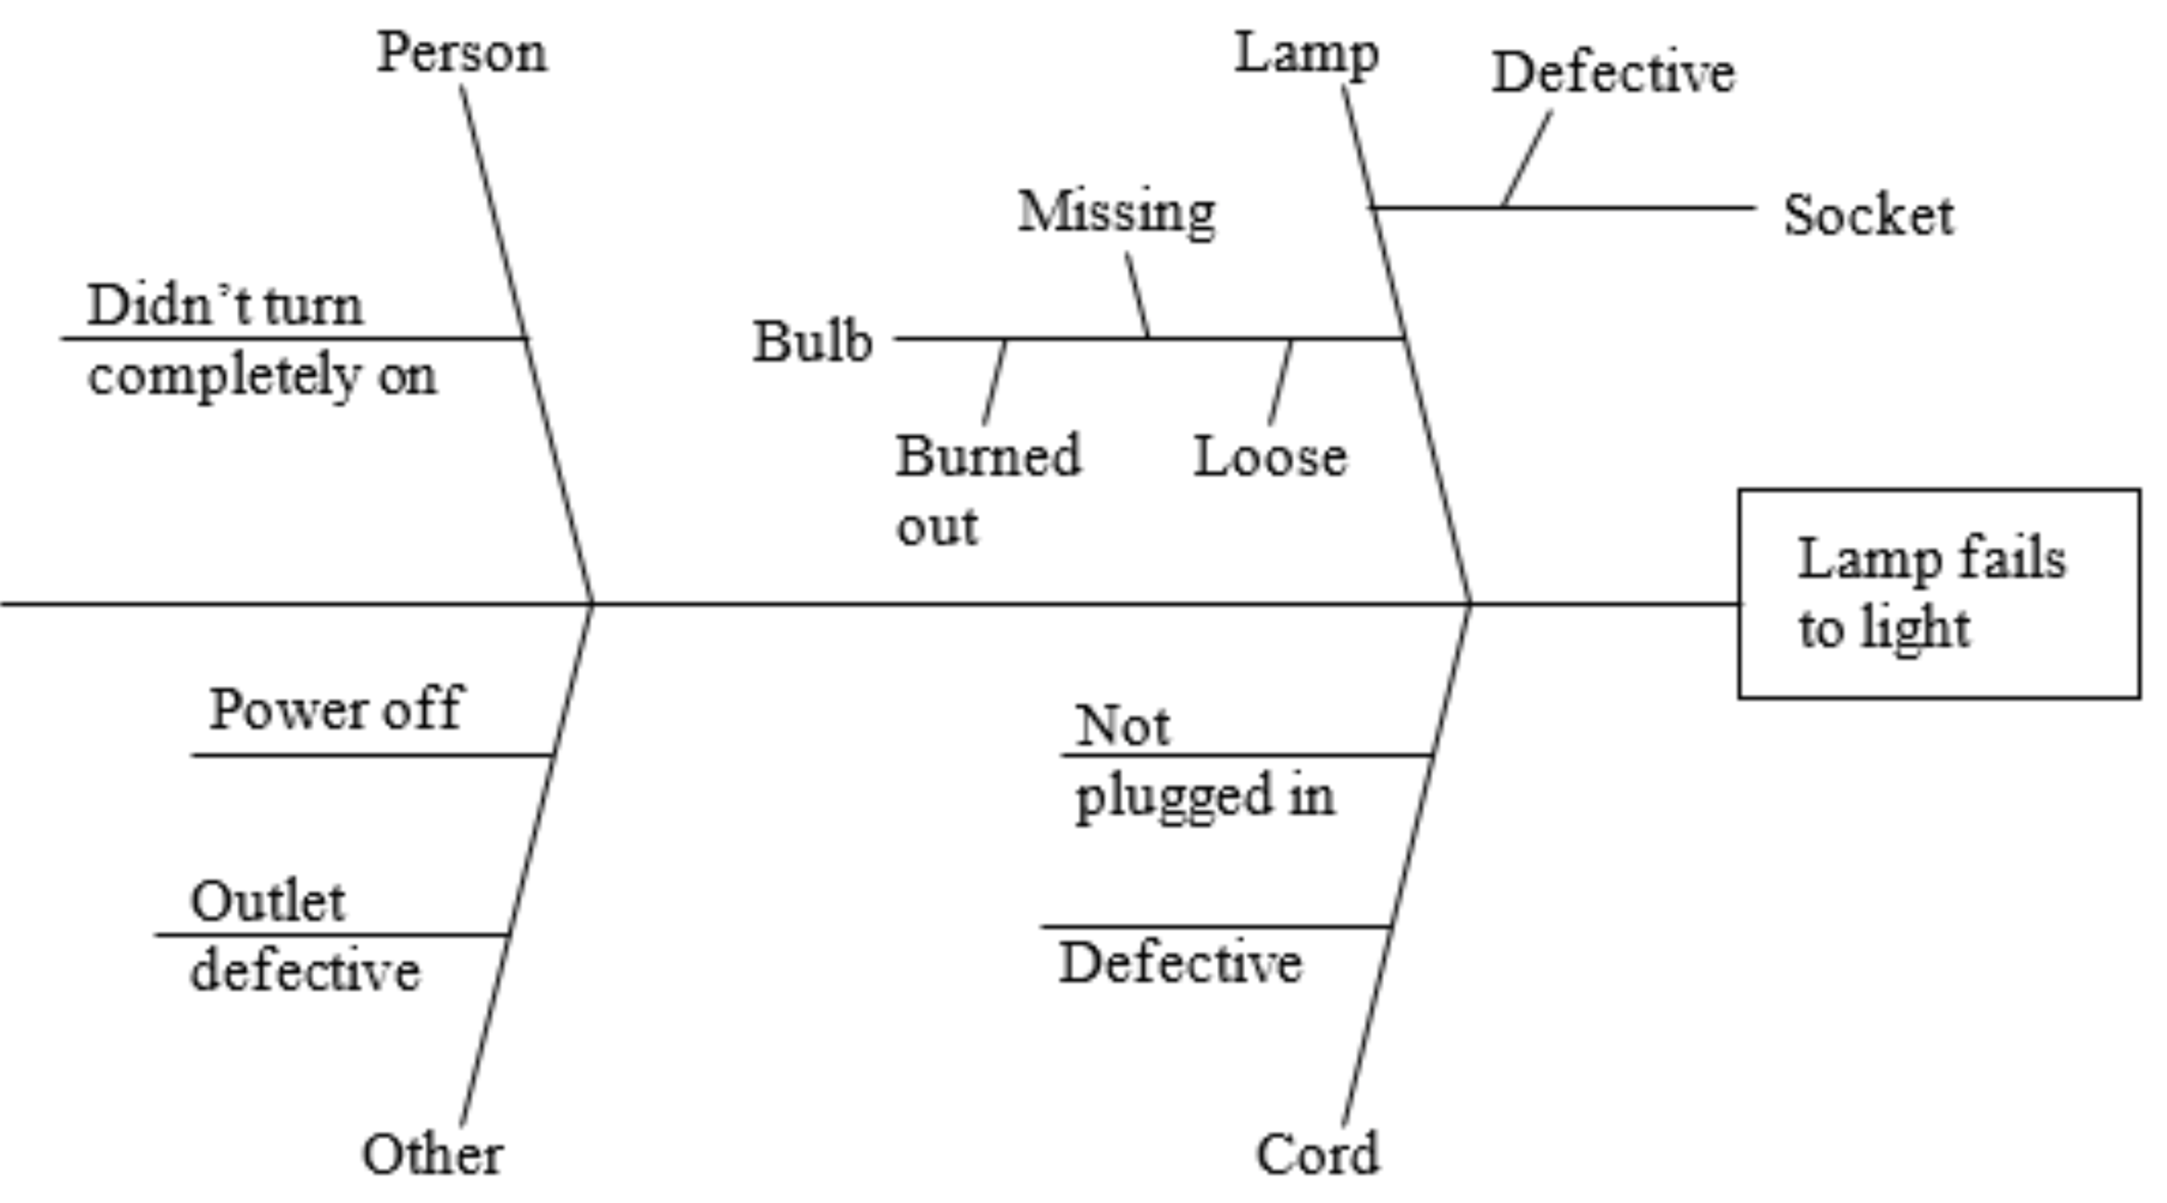

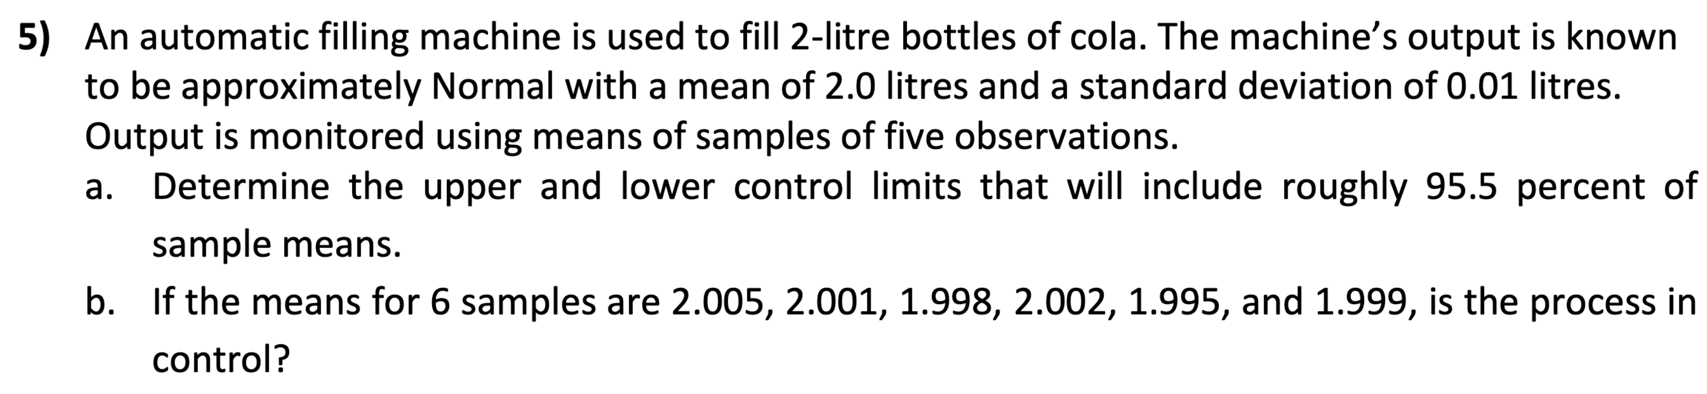

1. Control limits: $μ±z\frac{σ}{\sqrt{n}}$

$95.44\%→z=2$

$UCL=2.0+2\frac{0.01}{\sqrt{5}}=2.009 litres$

$LCL=2.0-2\frac{0.01}{\sqrt{5}}=1.991 litres$

1. Yes, because they all fall within the control limits and the pattern of data seems random.



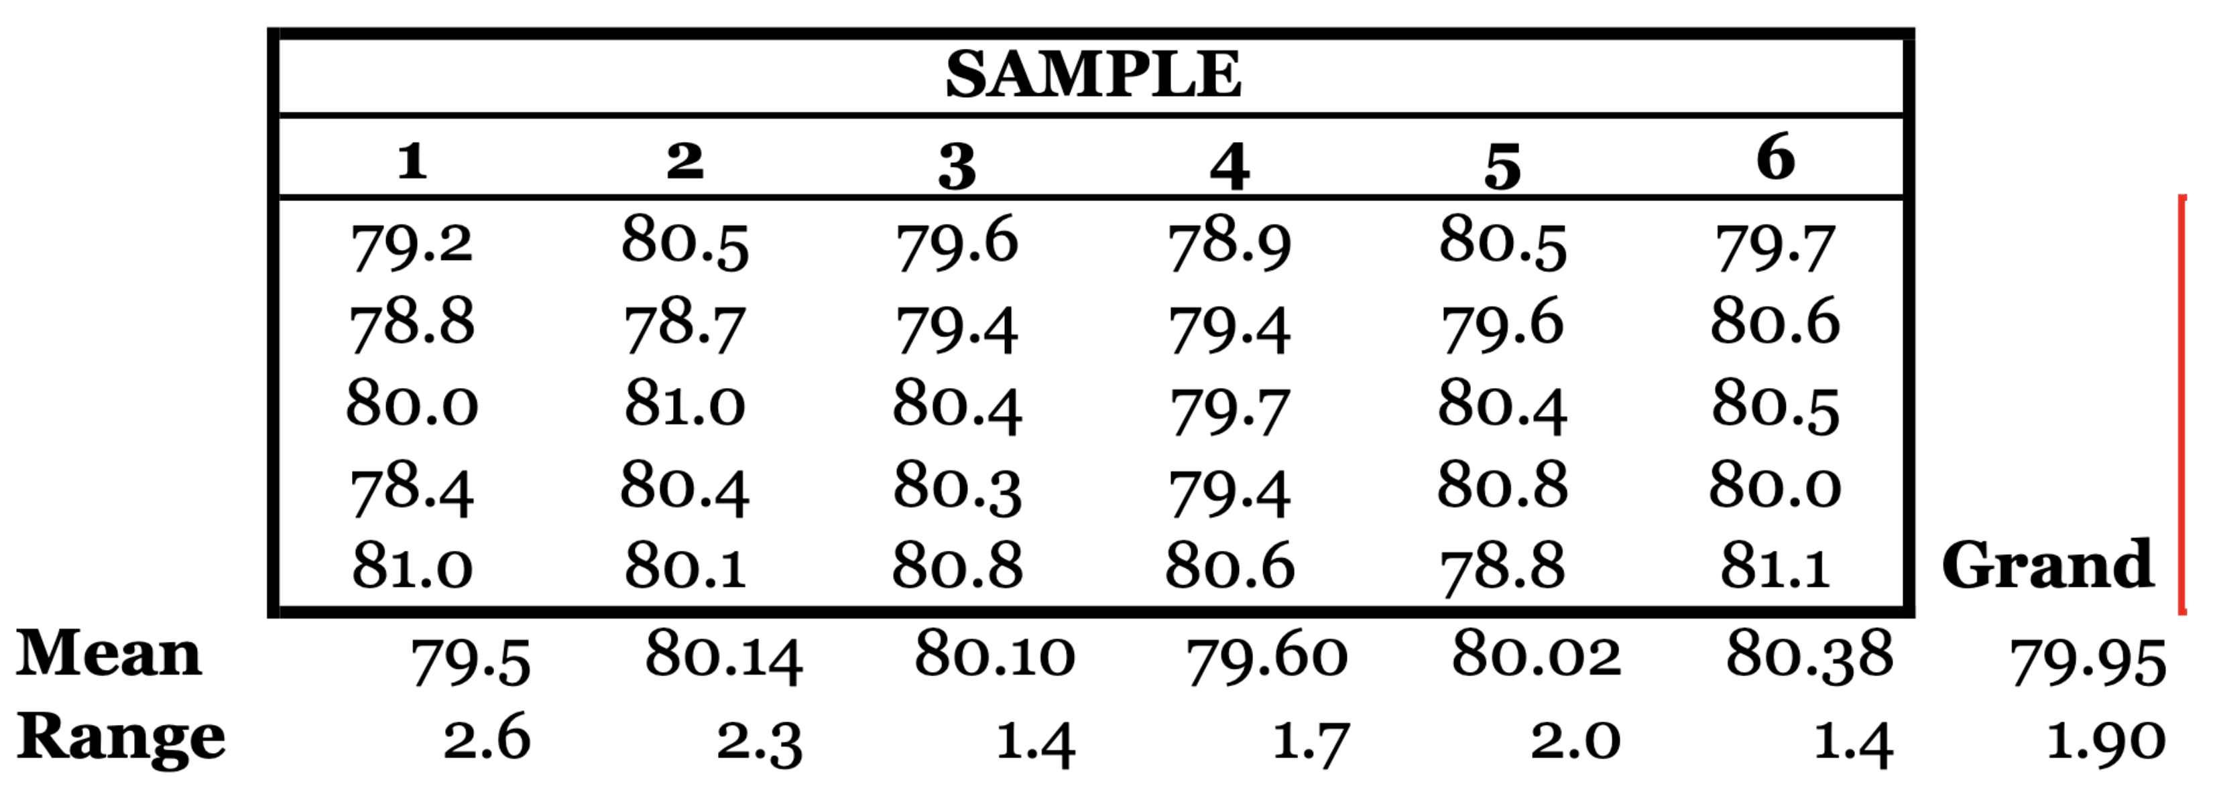

Mean control limits:

$$\overset{̿}{X}±A_{2}\overline{R}=79.95±0.58\left(1.90\right)=79.95±1.1$$

$$UCL=81.05, LCL=78.85$$

Range control limits:

$$UCL=D_{4}\overline{R}=2.11\left(1.90\right)=4.009$$

$$LCL=D_{3}\overline{R}=0\left(1.90\right)=0$$

Process is in control because all sample means and ranges fall within respective control limits.

7. Type I error concludes a process has changed when it actually has not, and Type II error concludes a process is in control when it is actually not.

# Tutorial 5: Supply Chain Management

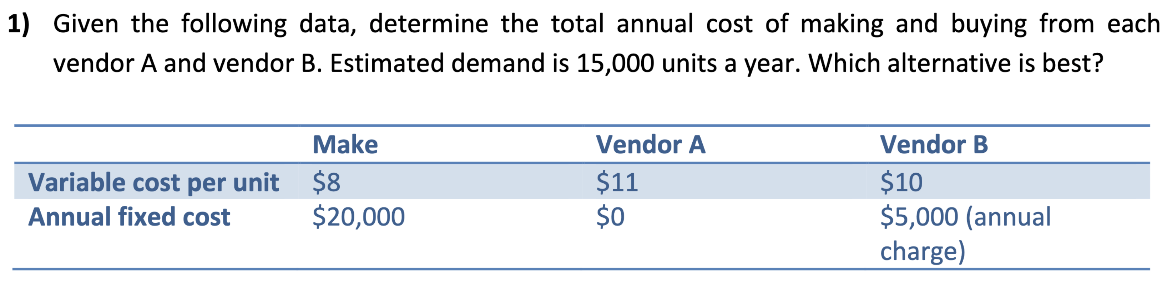

$$Total Annual Cost=Fixed Cost+Variable Cost Per Unit×Annual Quantity \\ Make: \$20,000+\$8×15,000=\$140,000 \\ Vendor A: \$0+\$11×15,000=\$165,000 \\ Vendor B:\$5,000+\$10×15,000=\$155,000$$

Thus, making the products yourself would be the best alternative.

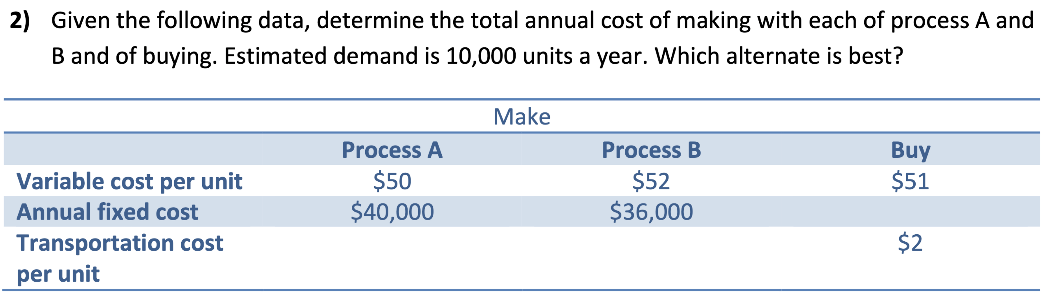

$$Process A: \$40,000+\$50×10,000=\$540,000 \\ Process B: \$36,000+\$52×10,000=\$556,000 \\ Buy: \$51×10,000+\$2×10,000=\$530,000$$

Thus, buying would have the lowest total annual cost.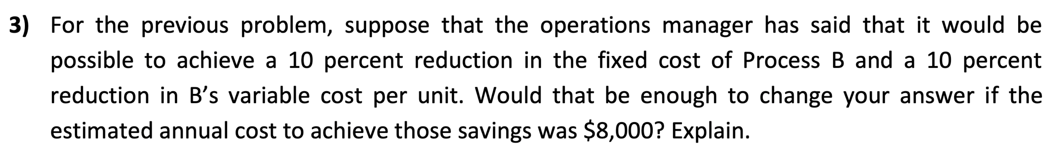

$$New Process B:\$36,000×0.9+\$8,000+\$52×0.9×10,000=\$508,400$$

Yes, the amount is less than buying, therefore make using Process B.

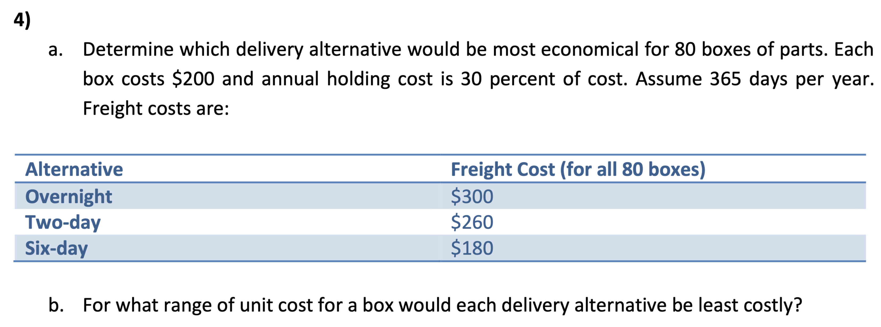



$$H=0.30×80 boxes×\$200=\$4,800$$

$Overnight: \$300+\$4800×\frac{1}{365}=\$313.15Two Day:\$260+\$4,800×\frac{2}{365}=\$286.30$ $Six Day: \$180+\$4,800×\frac{6}{365}=\$258.90$

Six-day alternative is cheapest.

1. $Let X=cost per box$. Then $H=24X$, and the total costs will be:

$$Overnight:\$300+\frac{24}{365}X$$

$$Two Day:\$260+\frac{48}{365}X$$

$$Six Day:\$180+\frac{144}{365}X$$

Overnight cheapest:

$$300+\frac{24}{365}X<260+\frac{48}{365}X⟹X>\$608.33 \\ 300+\frac{24}{365}X<180+\frac{144}{365}X⟹X>\$365.00$$

Two-day cheapest:

$$260+\frac{48}{365}X<300+\frac{24}{365}X⟹X<\$608.33$$

$$260+\frac{48}{365}X<180+\frac{144}{365}X⟹X>\$304.17$$

Six-day cheapest:

$$180+\frac{144}{365}X<300+\frac{24}{365}X⟹X<\$365.00$$

$$180+\frac{144}{365}X<260+\frac{48}{365}X⟹X<\$304.17$$

Overnight is cheapest if $unit cost>\$608.33$

Two-day cheapest if $\$304.17<unit cost<\$608.33$

Six-day cheapest if $unit cost<\$304.17$

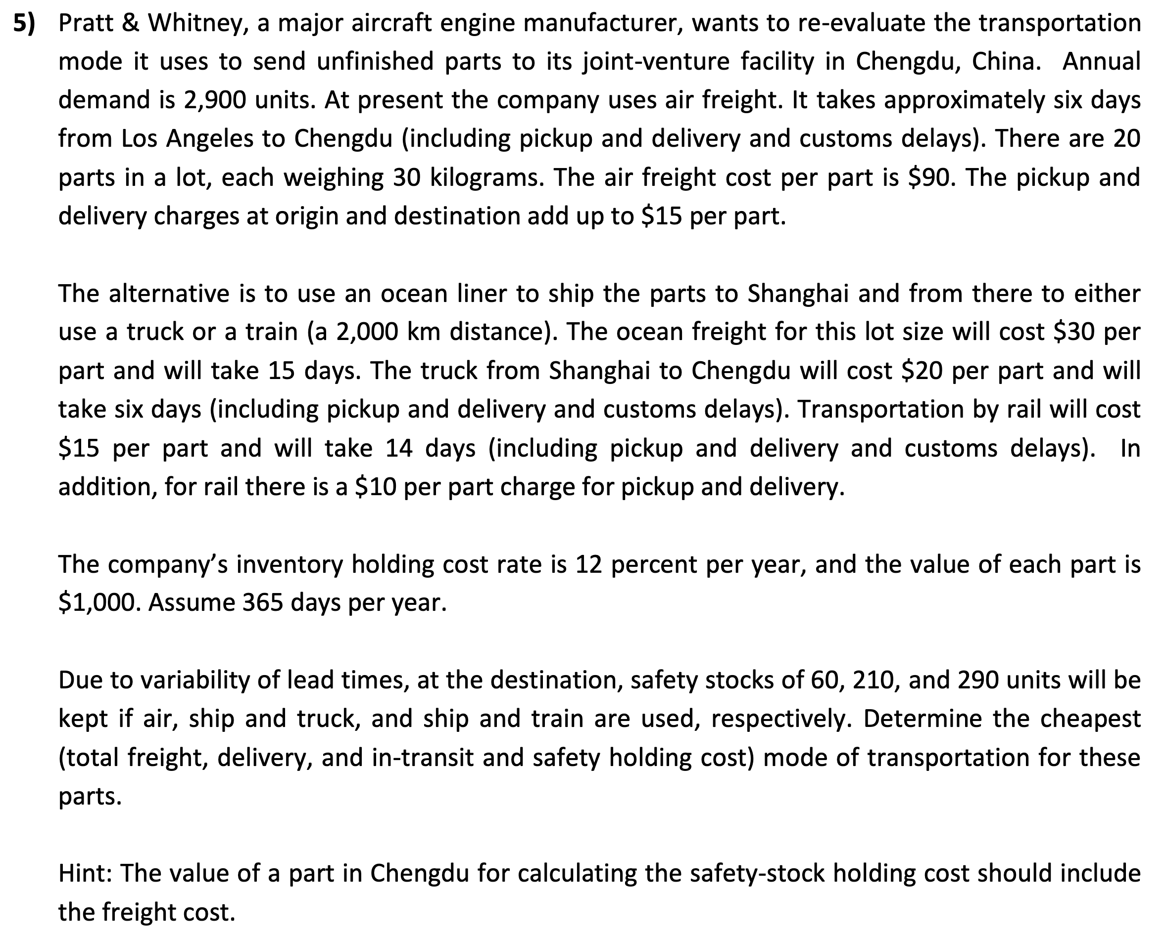

|  |  |  |
| --- | --- | --- |
| **Mode** | **Duration ($days$)** | **Cost ($\$$) Per Part** |
| Air | $$6$$ | $$90+15=105$$ |
| Ocean, Truck | $$15+6=21$$ | $$30+20=50$$ |
| Ocean, Train |  |  |

|  |  |
| --- | --- |
| **Mode** | **Annual Freight & Delivery Costs** |
| Air | $$\$105×2,900=\$304,500$$ |
| Ocean, Truck | $$\$50×2,900=\$145,000$$ |
| Ocean, Train | $$\$55×2,900=\$159,500$$ |
| **Mode** | **Annual In-Transit Holding Costs** |
| Air | $$\$1,000×0.12×\frac{6}{365}×2,900=\$5,720.55$$ |
| Ocean, Truck | $$\$1,000×0.12×\frac{21}{365}×2,900=\$20,021.92$$ |
| Ocean, Train |  |

|  |  |
| --- | --- |
| **Mode** | **Annual Safety Stock Holding Costs** |
| Air | $$60×\left(\$1,000+\$105\right)×0.12=\$7,956$$ |
| Ocean, Truck | $$210×\left(\$1,000+\$50\right)×0.12=\$26,460$$ |
| Ocean, Train |  |

|  |  |
| --- | --- |
| **Mode** | **Annual Total Cost** |
| Air | $$\$304,500+\$5,720.55+\$7,956=\$318,176.55$$ |
| Ocean, Truck | $$\$145,000+\$20,021.92+\$26,460=\$191,481.92$$ |
| Ocean, Train | $$\$159,500+\$27,649.32+\$36,714=\$223,863.32$$ |

The cheapest mode of transportation for these parts is by ocean and truck.